BSCS FINAL PROJECT

<Project Title>



Advisor: <Advisor Name>

Presented by:
Group ID: xxxxxxx

Student Reg# Student Name

Faculty of Information Technology

University of Central Punjab
Topic of Project (28 Pts. Bold)

By

NAME(S) OF PARTICIPTANT(s) (14 Pts. Normal)

Thesis/Project submitted to

Faculty of Information Technology,

University of Central Punjab,

Lahore, Pakistan.

in partial fulfillment of the requirements for the degree of

MASTER/ BACHELOR OF SCIENCE

IN
COMPUTER SCIENCE

Project Advisor |  | Manager Projects

Abstract
Sportswear customization in the e-commerce domain has long faced challenges related to user personalization, design accuracy, and seamless communication between buyers and sellers. To address these limitations, we developed SportWearXpress, an AI-driven platform aimed at revolutionizing the sportswear customization experience through automation, precision, and real-time interaction. Our solution leverages client-side AI tools for guided product customization, a dynamic pricing engine based on design complexity, and socket-based communication for live user-seller engagement. The system was fully implemented and tested across 16 core modules, resulting in a 100% pass rate for 32 structured test cases, covering user authentication, product customization, order processing, analytics, and refund workflows. Our deployment on a local environment successfully demonstrated low-latency AI processing and responsive front-end interactions under real-world usage scenarios. These outcomes validate the feasibility of a scalable, browser-based customization engine that can be adopted by SMEs or enterprise brands, indicating a strong potential for broader implementation across other e-commerce verticals.
Dedication
This project is dedicated with deep gratitude and respect to the people who have supported, inspired, and encouraged us throughout this journey.
First and foremost, we dedicate this work to our beloved parents and families, whose unwavering support, sacrifices, and constant encouragement have been the foundation of our academic pursuits. Your belief in us gave us the strength to overcome challenges and keep striving for excellence, even during the most difficult phases.
We also extend this dedication to our esteemed project advisor, Ms. Anum Mustaqeem, whose guidance, insight, and valuable feedback played a pivotal role in shaping our ideas and improving our system throughout the development phases. Her constructive criticism and mentorship were instrumental in keeping us focused and motivated.
To our teachers and faculty at the University of Central Punjab, we express our appreciation for imparting knowledge and developing in us the skills necessary to turn ideas into working solutions. Your dedication to teaching and mentorship laid the groundwork for this successful project.
We also dedicate this work to our teammates and fellow batchmates who contributed with collaboration, healthy competition, and continuous moral support. The shared experiences, long hours of brainstorming, and collaborative problem-solving will always remain memorable.
Finally, we dedicate this project to all aspiring students and developers who dream of building something impactful. May this work serve as a small source of inspiration and a reminder that with the right mindset, teamwork, and determination, innovative ideas can be transformed into real-world solutions.

Acknowledgements
We would like to express our heartfelt gratitude to all those who supported and guided us throughout the development of our final year project, SportWearXpress.
First and foremost, we are deeply thankful to Allah Almighty for granting us the strength, patience, and perseverance to complete this project successfully.
We would like to extend our sincere appreciation to our project advisor, Ms. Anum Mustaqeem, for her exceptional mentorship, continuous guidance, and valuable feedback throughout every phase of this project. Her encouragement, insights, and deep understanding of software development helped us stay focused and motivated.
Our sincere thanks also go to the Faculty of Information Technology & Computer Science at the University of Central Punjab for providing the academic foundation and practical experience necessary for carrying out such a complex project. The knowledge and skills imparted by our professors throughout the years were instrumental in shaping our technical and problem-solving abilities.
We would also like to acknowledge the lab instructors and support staff who assisted us in configuring systems and managing the development environment.
Special thanks to our families for their constant support, encouragement, and prayers throughout this journey. Without their patience and belief in us, this achievement would not have been possible.
Lastly, we are grateful to our teammates for their collaboration, trust, and dedication. This project was the result of our combined efforts, and the journey has been both challenging and rewarding.
Thank you all for being part of this milestone in our academic life.

List of Figures

Provide a list of all figures along with their captions
List of Tables

Provide a list of all tables along with their captions
List of Illustrations

Provide a list of illustrations, if any, along with their captions. Remove this page if there are no illustrations
Table of Contents
Abstract i
Dedication ii
Acknowledgements iii
List of Figures iv
List of Tables v
List of Illustrations vi
Table of Contents vii
Revision History ix
Chapter 1. Introduction 1
1.1 Product (Problem Statement) 1
1.2 Background 1
1.3 Objective(s)/Aim(s)/Target(s) 1
1.4 Scope 1
1.5 Business Goals 1
1.6 Challenges 2
1.7 Learning Outcomes 2
1.8 Nature of End Product 2
1.9 Related Work/ Literature Survey/ Literature Review 2
1.10 Document Conventions 2
1.11 Miscellaneous 2
Chapter 2. Overall Description 3
2.1 Product Features 3
2.2 Functional Description 3
2.3 User Classes and Characteristics 3
2.4 Design and Implementation Constraints 3
2.5 Assumptions and Dependencies 3
Chapter 3. System Requirements 4
3.1 Functional Requirements 4
3.1.1 Name of Use-Case 1 4
3.1.2 Name of Use-Case 2 (and so on) 4
3.1.3 Requirements Analysis and Modeling 4
3.2 Nonfunctional Requirements 6
3.2.1 Performance Requirements 6
3.2.2 Safety Requirements 6
3.2.3 Security Requirements 6
3.2.4 Additional Software Quality Attributes 6
3.3 Other Requirements 6
Chapter 4. Technical Architecture 7
4.1 Application and Data Architecture 7
4.2 Component Interactions and Collaborations 8
4.3 Design Reuse and Design Patterns 8
4.4 Technology Architecture 8
4.5 Architecture Evaluation 8
Chapter 5. Detailed Design and Implementation 9
5.1 Component-Component Interface 9
5.2 Component-External Entities Interface 9
5.3 Component-Human Interface 9
5.4 Screenshots/Prototype 9
5.4.1 Workflow 9
5.4.2 Screens 9
5.5 Additional Information 9
5.6 Other Design Details 9
Chapter 6. Test Specification and Results 10
6.1 Test Case Specification 10
6.2 Summary of Test Results 11
Chapter 7. Project Completion Status/Conclusion 11
References 12
Appendix A Glossary 12
Appendix B IV & V Report 13
(Independent verification & validation) 13
Appendix C Deployment/Installation Guide 13
Appendix D User Manual 13

Revision History
Name | Date | Reason For Changes | Version

Introduction

Product (Problem Statement)
SportWearXpress is a web-based e-commerce platform developed to solve the challenges of personalized sportswear customization. Traditional platforms lacked intelligent design assistance, dynamic pricing, and real-time communication, often resulting in user frustration and order errors.
Our system provided an AI-powered customization tool that guided users in designing their own sportswear, calculated prices based on complexity, and enabled live chat between buyers and sellers. This reduced miscommunication, improved accuracy, and enhanced customer satisfaction.

Background
Previous platforms in the sportswear customization domain, like Zazzle and Custom Ink, offered basic design tools but lacked intelligent guidance, real-time interaction, and dynamic pricing. Most relied on static templates, leading to limited user control and increased errors.
In contrast, SportWearXpress introduced AI-based customization, live chat support, and automatic pricing based on design complexity. Unlike earlier UCP projects that focused mainly on static e-commerce or inventory systems, this project combined advanced features into a single, smart platform, offering a more interactive and efficient user experience.

Objective(s)/Aim(s)/Target(s)
- Built an AI-powered sportswear customization platform.
- Added dynamic pricing based on design complexity.
- Enabled real-time buyer-seller chat.
- Provided user, seller, and admin dashboards.
- Improved design accuracy and customer satisfaction.
Research Contribution:
Proved how AI and real-time features improve e-commerce customization.

Scope
The scope of SportswearXpress includes essential features aimed at enhancing the sportswear customization experience:

- User Customization Interface: A web platform for creating personalized sportswear designs with various options.
- AI-Powered Design Tools: Intelligent tools that guide users through the customization process.
- AI Chatbot: Real-time assistance and recommendations throughout the design journey.
- Dynamic Pricing Model: Automatic adjustments of prices based on customization complexity.
- Real-Time Communication: Direct interaction between customers and sellers for immediate support.
- User Account Management: Secure accounts for saving designs and tracking order history.
- Administrative Dashboard: Tools for sellers to manage products and analyze customer interactions.
- Testing and Deployment: Comprehensive testing before launch and ongoing maintenance for continuous improvement.

Business Goals
SportswearXpress aims to achieve the following business objectives:
- Enhancing Customer Satisfaction: Elevate customer satisfaction by providing intuitive and precise customization options that cater to individual preferences.
- Minimizing Design Errors: Decrease design errors and miscommunication through the implementation of AI-driven guidance and real-time communication tools.
- Optimizing Operational Efficiency: Streamline operations by automating design assistance and dynamic pricing adjustments, allowing for a more efficient workflow.
- Setting Industry Standards: Establish a competitive benchmark in the sportswear sector by delivering innovative, AI-powered e-commerce solutions that redefine customer engagement.

Challenges
- Integrating AI tools with real-time performance.
- Ensuring smooth buyer-seller communication using Socket.io.
- Managing state and data flow in a complex UI with React.js.
- Handling dynamic pricing logic accurately.
- Testing edge cases and ensuring system stability.

Learning Outcomes
- Gained hands-on experience in full-stack development (React.js, Node.js, MongoDB).
- Learned how to integrate AI tools in web applications.
- Improved skills in real-time communication using Socket.io.
- Understood project deployment, testing, and version control.
- Enhanced teamwork, problem-solving, and documentation skills.

Nature of End Product
The end product is a complete, web-based software system designed for personalized sportswear customization. It offers an AI-powered design assistant, real-time chat between buyers and sellers, and an automated dynamic pricing engine. The system includes dedicated dashboards for users, sellers, and admins, covering all major functionalities of an e-commerce platform. It is fully developed, tested, and ready for real-world deployment or further scaling. Related Work/ Literature Survey/ Literature Review

Related Work/ Literature Survey/ Literature Review

Document Conventions
This SRS follows the standard format for software requirements specifications. The document utilizes the following conventions: Font Styles: Section headings are in bold font of 14 Times, while subsection headings are in bold of size 12. Regular text is used for descriptions and content. Highlighting: Important terms or concepts may be highlighted using bold or italic font for emphasis. Numbering: Sections organization and reference purposes. and subsections are numbered sequentially Nomenclature: Where applicable, technical terms or acronyms are defined upon first use to ensure clarity and understanding throughout the document.

Miscellaneous
- The project uses modern tools like React.js, Node.js, MongoDB, and TensorFlow.js.
- Version control was managed through GitHub.
- Real-time features were built using Socket.io.
- The system was tested locally and is deployment-ready.
- Future upgrades may include AR-based previews and payment gateway integration.

Overall Description

Product Features
AI-Powered Design Tools: Intuitive tools guide users step-by-step through the customization process, ensuring precision and ease.
Dynamic Pricing Model: Automatic pricing adjustments based on the complexity of each design, ensuring transparency and fairness.
Real-Time Communication: Direct interaction between users and sellers to provide immediate support and clarify customization needs.
User Customization Interface: A user-friendly web platform with a wide array of customization options for personalized sportswear designs.
AI Chatbot: Provides real-time assistance and personalized recommendations throughout the design process. User Account Management: Secure user accounts for saving designs and tracking order history.
Administrative Dashboard: Tools for sellers to manage products, track customer interactions, and analyze performance

Functional Description
The system allows users to design custom sportswear using AI tools, view dynamic pricing, and communicate with sellers in real-time. Sellers can manage products, view orders, and respond to customers. Admins can monitor platform activity, manage users, and view analytics. All modules interact through a centralized backend, ensuring smooth data flow and user management.

User Classes and Characteristics
- Casual Users
  - Frequency of Use: Occasional
  - Functions Used: Basic customization tools and browsing
  - Technical Expertise: Low to moderate
  - Characteristics: Seek easy-to-use interfaces and quick customization options. Prefer straightforward and engaging experiences.

Frequent Customizers
  - Frequency of Use: Regular
  - Functions Used: Advanced design tools, frequent design adjustments
  - Technical Expertise: Moderate to high
  - Characteristics: Comfortable with complex customization features. Value precision and detailed design options. Often return for multiple orders

Professional Designers
  - Frequency of Use: High
  - Functions Used: Full suite of design tools, bulk customization
  - Technical Expertise: High
  - Characteristics: Demand robust design functionalities and seamless workflow integration. Focus on efficiency and high-quality outputs.

Sellers/Admins
  - Frequency of Use: Daily
  - Functions Used: Product management, customer interaction, analytics
  - Technical Expertise: High
  - Characteristics: Require comprehensive tools for inventory management, real-time communication, and sales analytics. Prioritize operational efficiency and customer satisfaction.

AI Chatbot Users
  - Frequency of Use: Varies
  - Functions Used: Customer support and design guidance
  - Technical Expertise: Low to moderate
  - Characteristics: Seek quick and helpful responses to inquiries. Rely on AI guidance for design and troubleshooting.

Design and Implementation Constraints
- Corporate or Regulatory Policies:
  - Compliance with industry regulations and standards related to e- commerce and data privacy (e.g., GDPR, CCPA) is mandatory.
  - Adherence to corporate policies regarding user data handling and storage to ensure privacy and security.
- Hardware Limitations:
  - Must operate efficiently on devices with limited processing power and memory capacity, ensuring performance across various hardware specifications.
  - Timing requirements for real-time communication and dynamic pricing adjustments may pose constraints on system performance.
- Interfaces to Other Applications:
  - Integration with existing e-commerce platforms or third-party services ( e.g., payment gateways, shipping services) may limit customization options.
  - Dependencies on APIs for functionalities like map services, voice recognition, and image processing.
- Specific Technologies, Tools, and Databases:
Utilizing technologies like TensorFlow.js, OpenCV, and Socket.io limits the choice of programming languages and development frameworks.
  - Databases must support rapid data retrieval and real-time updates, influencing the choice of database management systems.
- Parallel Operations:
  - The platform must support simultaneous user interactions and real-time updates, requiring robust concurrency management.
  - Parallel operations may necessitate load balancing and efficient resource allocation to maintain performance.

Assumptions and Dependencies
- Assumed Factors:
Third-Party Components: It is assumed that third-party components such as TensorFlow.js for AI functionalities, OpenCV for image processing, and Socket.io for real-time communication will continue to be supported and updated.
- Development Environment: Assumes that development will occur in a stable environment with access to necessary tools, libraries, and frameworks.
- Operating Environment: Assumes compatibility with popular operating systems including Windows, macOS, iOS, and Android, and that these systems will remain stable and continue to support the application requirements.
- Dependencies:

- External Software Components:
The project relies on external software components like messenger platforms for communication between buyers and sellers. This dependency means that changes or disruptions in these platforms could impact payment discussions and updates on orders.
- Technology Stack:
MongoDB for data storage, Konva.js for enabling product design tools, and AI libraries like TensorFlow.js are critical to the platform. Updates or deprecations in these technologies may require significant modifications to maintain functionality.
- APIs and Services:
Integration with APIs for AI-driven customization, image processing, and real-time communication is essential. Changes or interruptions in these APIs could impact features like product design guidance, chatbot interaction, and design visualization.
- Hardware Dependencies:
Users need compatible devices with sufficient processing power and stable internet connectivity to utilize the interactive design tools and communicate with the seller efficiently. Limitations in user hardware or connectivity might affect the overall experience.

System Requirements

Functional Requirements
- User Registration
- User Login
- Product Customization
- Add to Cart
- Place Order
- Payment Processing
- Order Tracking
- Product Review
- Interact with Sellers
- Dynamic Pricing Model
- Database Integration
- Report Generation
- Check Customization Status
- Save Product Design

Use-Case Diagram:
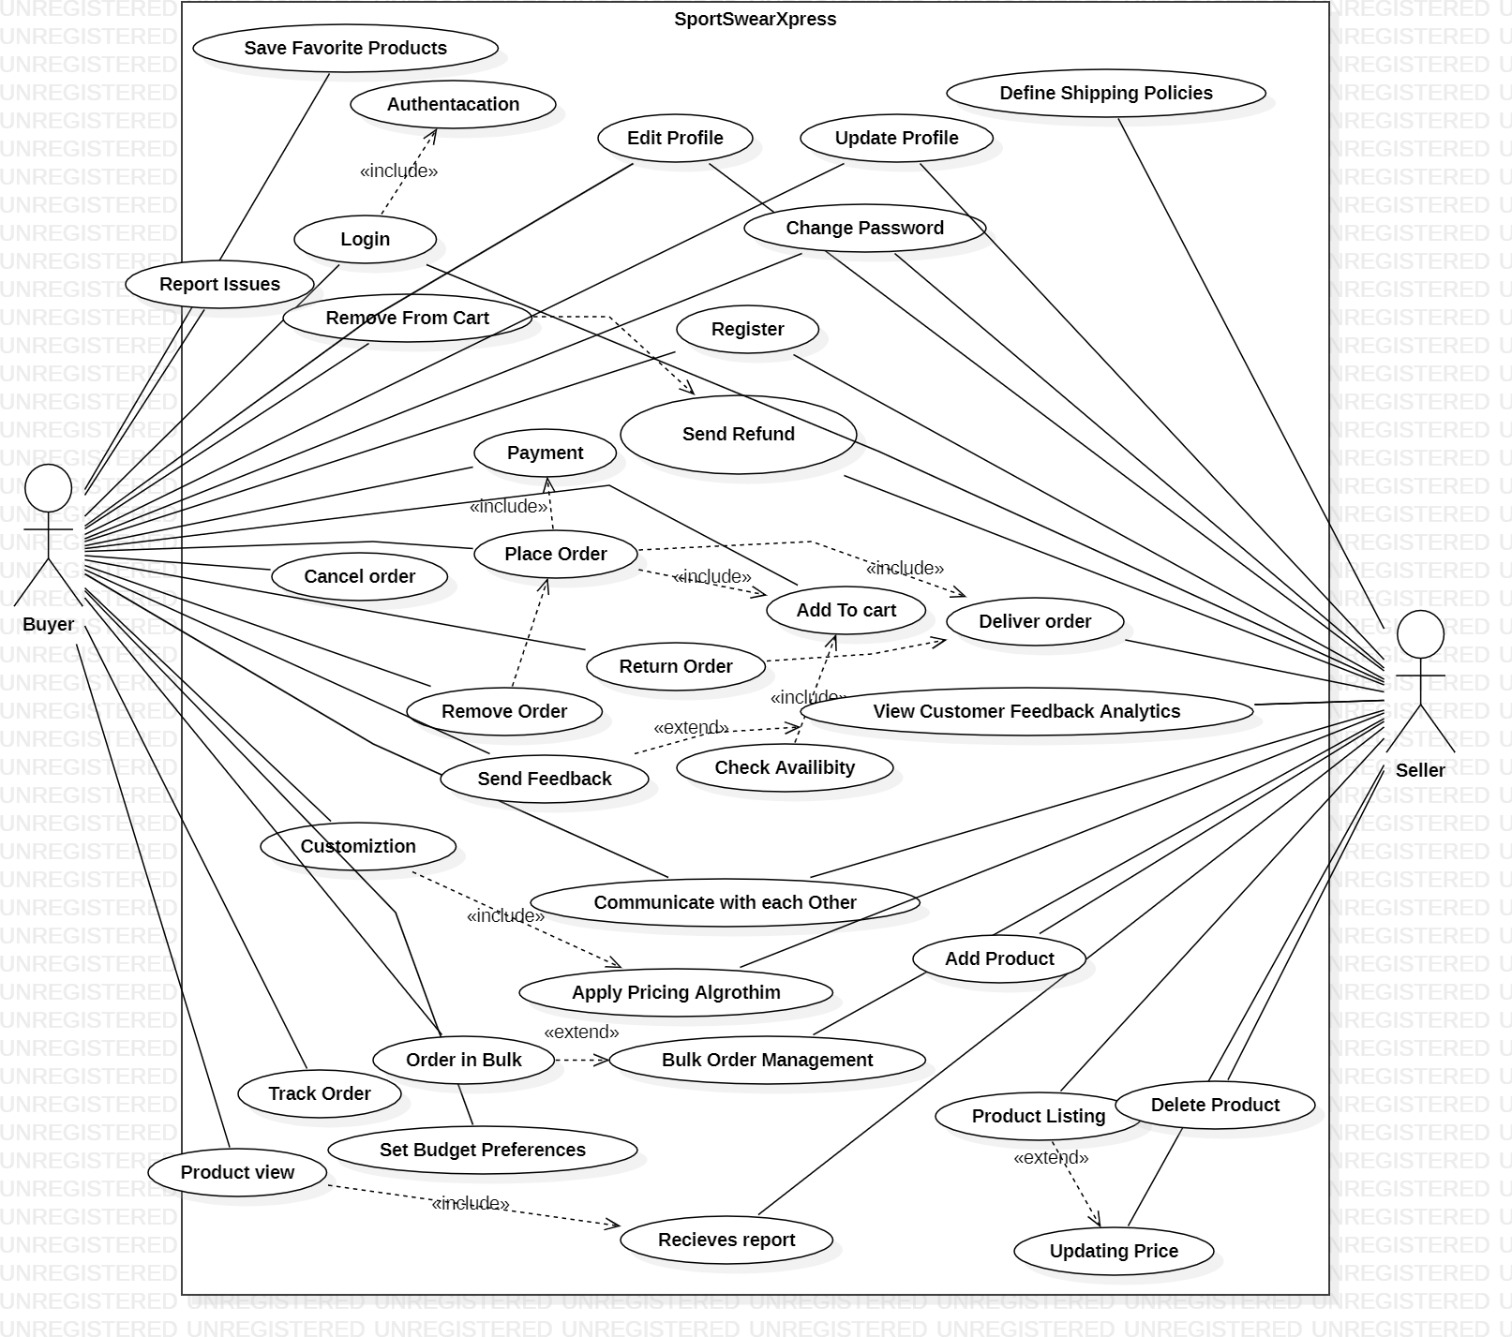

User Authentication and Profile Management

Identifier |  | UC-1
Purpose |  | To allow users to securely log in, log out, and manage their profile.
Priority |  | High
Pre-conditions |  | User must have an account with a registered email and password.
Post- conditions |  | User is logged in and has access to profile management features, or receives an error message if login fails.
Typical Course of Action
S# | Actor Action |  | System Response
1 | User navigates to the login page. |  | System displays the login form.
2 | User enters email and password and submits. |  | System validates credentials.
3 | Credentials are correct. |  | System logs user in and redirects to profile page.
4 | User navigates to the profile management page. |  | System displays profile information and edit options.
4 | User updates profile information and submits. |  | System saves changes and confirms update success.
Alternate Course of Action
S# | Actor Action |  | System Response
1 | User enters incorrect email or password. |  | System displays an error message.
2 | User attempts to access profile management without logging in. |  | System redirects to login page.
3 | User forgets password and clicks "Forgot Password." |  | System sends a password reset email.
…
Table 1: UC-1

Add to Cart

Purpose |  | To allow users to add items to their shopping cart for purchase.
Priority |  | High
Pre-conditions |  | - User must be logged into their account.  - The item to be added must be in stock.
Post- conditions |  | - The item is added to the cart.  - Cart reflects the updated total cost and quantity.
Typical Course of Action
S# | Actor Action |  | System Response
1 | User selects an item to add to the cart. |  | System fetches item details.
2 | User clicks the "Add to Cart" button. |  | System checks item availability.
3 |  |  | System adds the item to the cart and updates the cart details (item count and total price).
4 | System confirms the addition of the item. |  | Display confirmation message: "Item added to cart successfully.
Alternate Course of Action
S# | Actor Action |  | System Response
1 | User selects an out-of-stock item. |  | System displays a message: "Item is out of stock."
2 | User tries to add an invalid item. |  | System displays a message: "Invalid item."
3 | User adds the last available unit of an item. |  | System marks the item as "Out of Stock" after addition.
Table 2: UC-2

Product Customization

Identifier |  | UC-3
Purpose |  | To allow users to customize products (e.g., colors, text, designs) before adding them to their cart.
Priority |  | High
Pre-conditions |  | - User must be logged into their account.  - He product must support customization.  - The customization tool should be available and functional.
Post- conditions |  | - Customization is saved and linked to the product in the cart.  - The system displays the customized product for review.
Typical Course of Action
S# | Actor Action |  | System Response
1 | User selects a product that supports customization. |  | System fetches and displays the customization interface.
2 | User chooses customization options such as color, text, or design. |  | System updates the preview to reflect the selected customizations.
3 | User confirms the customization. |  | System saves the customization and calculates the updated price (if applicable).
4 | User clicks "Add to Cart" after customization. |  | System adds the customized product to the cart and displays a confirmation message.
Alternate Course of Action
S# | Actor Action |  | System Response
1 | User selects a product that does not support customization. |  | System displays a message: "Customization not available for this product."
2 | User inputs invalid customization details (e.g., invalid characters or file formats). |  | System prompts an error message: "Invalid customization input. Please correct it."
3 | User attempts to save customization during a system error. |  | System displays a message: "Unable to save customization. Please try again later."
Table 3: UC-3

Save Product Design

Identifier |  | UC-4
Purpose |  | To allow users to save a customized product design for future use or purchase.
Priority |  | Medium
Pre-conditions |  | - User must be logged into their account.  - Customization is completed and ready to save.
Post- conditions |  | - The product design is saved in the user's profile under "Saved Designs".
Typical Course of Action
S# | Actor Action |  | System Response
1 | User clicks "Save Design" after completing product customization. |  | System validates the customization details and displays a message: "Saving design...".
2 | User provides a name for the design (optional). |  | System saves the design with the provided name or assigns a default name if none is provided.
3 | Typical: System confirms: "Design saved successfully" and makes it available in the "Saved Designs" section. |  | Typical Continuation: Saved design appears in the user's account for future access.
Alternate Course of Action
S# | Actor Action |  | System Response
1 | Alternative: User attempts to save without completing customization. |  | Alternative Response: System displays an error: "Customization incomplete. Please complete your design before saving."
2 | Alternative: User attempts to save during a system error (e.g., connection loss). |  | Alternative Response: System displays: "Unable to save the design. Please check your connection and try again later."
3 | Alternative: User attempts to save a duplicate design name. |  | Alternative Response: System prompts: "Design name already exists. Please choose a unique name."
Table 4: UC-4

Adjust Pricing

Identifier |  | UC-5
Purpose |  | To allow administrators to adjust product pricing dynamically based on factors such as demand, discounts, or promotions.
Priority |  | High
Pre-conditions |  | - Admin must be logged into the system with the necessary permissions.  - Product must already exist in the system.
Post- conditions |  | - The updated price is reflected in the system and visible to customers.
Typical Course of Action
S# | Actor Action |  | System Response
1 | Admin selects a product to adjust pricing. |  | System displays the current price and pricing history.
2 | Admin inputs a new price or applies a discount percentage. |  | System validates the new price (e.g., checks against minimum price thresholds).
3 | Admin confirms the adjustment. |  | System updates the product price and logs the change in the pricing history. Customers see the updated price.
Alternate Course of Action
S# | Actor Action |  | System Response
1 | Admin selects a product to adjust pricing. |  | System displays the current price and pricing history.
2 | Admin inputs a new price or applies a discount percentage. |  | System validates the new price (e.g., checks against minimum price thresholds).
3 | Admin confirms the adjustment. |  | System updates the product price and logs the change in the pricing history. Customers see the updated price.
Table 5: UC-5

Track Design Changes

Identifier |  | UC-6
Purpose |  | To allow users to track and review the changes made to a product design during customization.
Priority |  | Medium
Pre-conditions |  | - User must be logged into their account.  - Design changes must be saved in the system.
Post- conditions |  | - User can view and revert to a previous version of the design if required.
Typical Course of Action
S# | Actor Action |  | System Response
1 | User accesses the "Track Changes" option for a customized product. |  | System displays a list of all changes made to the design in chronological order.
2 | User selects a specific change to review. |  | System provides a preview of the design at that specific stage.
3 | User reverts to a previous design version (if required). |  | System confirms the reversion and updates the current design to reflect the selected version.
Alternate Course of Action
S# | Actor Action |  | System Response
1 | User tries to access changes for a product without saved versions. |  | System displays: "No design changes available for this product."
2 | User attempts to revert during a system error. |  | System displays: "Unable to process the request. Please try again later."
Table 6: UC-6

Place Order

Identifier |  | UC-7
Purpose |  | To allow users to place an order for customized or standard products.
Priority |  | High
Pre-conditions |  | - User must be logged in.  - Cart must contain at least one product.
Post- conditions |  | 1. The order is placed, and the user receives an order confirmation.
Typical Course of Action
S# | Actor Action |  | System Response
1 | User proceeds to checkout. |  | System displays the order summary and total cost.
2 | User enters shipping and payment details. |  | System validates the details and confirms the payment.
3 | User confirms the order. |  | System processes the order and displays a confirmation message with an order ID.
Alternate Course of Action
S# | Actor Action |  | System Response
1 | User tries to checkout with an empty cart. |  | System displays: "Your cart is empty. Please add items before proceeding."
2 | User enters invalid payment details. |  | System prompts: "Payment failed. Please check your details and try again."
3 | User cancels the order during checkout. |  | System discards the order and returns the user to the cart.
Table 7: UC-7

Track Order

Identifier |  | UC-8
Purpose |  | To allow users to track the status of their placed orders.
Priority |  | Medium
Pre-conditions |  | - User must be logged in.  - User must have at least one active order.
Post- conditions |  | - User can view the current status and estimated delivery time.
Typical Course of Action
S# | Actor Action |  | System Response
1 | User accesses the "Track Order" section. |  | System displays a list of all active orders.
2 | User selects a specific order to track. |  | System displays the current status, location, and estimated delivery time.
Alternate Course of Action
S# | Actor Action |  | System Response
1 | User tries to track an order that does not exist. |  | System displays: "No orders found to track."
2 | User tries to track during a system outage. |  | System displays: "Unable to fetch order details. Please try again later."
Table 8: UC-8

Interact with Seller

Identifier |  | UC-9
Purpose |  | To allow users to communicate with sellers for queries about products or orders.
Priority |  | Medium
Pre-conditions |  | - User must be logged in.  - Seller contact must be enabled for the product.
Post- conditions |  | - Messages are successfully sent and received between the user and the seller.
Typical Course of Action
S# | Actor Action |  | System Response
1 | User selects the "Contact Seller" option for a product or order. |  | System opens a chat or messaging interface.
2 | User sends a message to the seller. |  | System delivers the message to the seller and confirms delivery.
3 | User receives a reply from the seller. |  | System notifies the user of the new message and displays it in the chat interface.
Alternate Course of Action
S# | Actor Action |  | System Response
1 | User tries to contact a seller for a product without contact support. |  | System displays: "This seller cannot be contacted directly."
2 | User sends a message during a system error. |  | System displays: "Message failed to send. Please try again later."
Table 9: UC-9

Product Reviews and Ratings

Identifier |  | UC-10
Purpose |  | To allow users to leave reviews and ratings for purchased products.
Priority |  | Medium
Pre-conditions |  | 1. User must have purchased the product.
Post- conditions |  | 1. Review and rating are saved and displayed on the product page.
Typical Course of Action
S# | Actor Action |  | System Response
1 | User selects a purchased product to review. |  | System opens the review and rating interface.
2 | User writes a review and provides a rating (e.g., 1–5 stars). |  | System validates the input and displays a confirmation message.
3 | User submits the review. |  | System saves the review and updates the product’s review section.
Alternate Course of Action
S# | Actor Action |  | System Response
1 | User tries to review a product they have not purchased. |  | System displays: "Only purchased products can be reviewed."
2 | User submits an incomplete review (e.g., no text or rating). |  | System displays: "Please provide both a rating and a review before submitting."
3 | User attempts to submit during a system outage. |  | System displays: "Unable to submit your review. Please try again later."
Table 10: UC-10

Analytics and Reporting

Identifier |  | UC-11
Purpose |  | To provide administrators with analytics and reports on user behavior, sales, and system performance.
Priority |  | Medium
Pre-conditions |  | Admin must be logged in.
Post- conditions |  | Admin views detailed reports and analytics.
Typical Course of Action
S# | Actor Action |  | System Response
1 | Admin accesses the analytics section. |  | System loads available reports and data visualization tools.
2 | Admin selects a report to view (e.g., sales, user activity). |  | System generates and displays the selected report.
3 | Admin filters or sorts the report data. |  | System updates the report view according to the selected filters.
4 | Admin exports the report data to a file (e.g., CSV). |  | System generates and downloads the requested report file.
Alternate Course of Action
S# | Actor Action |  | System Response
1 | Admin tries to access unavailable report data. |  | System displays an error message and suggests alternative options.
2 | Admin selects an invalid date range for the report. |  | System prompts the admin to choose a valid date range.
3 | Admin’s request for a large dataset fails. |  | System notifies the admin about performance issues and suggests a smaller dataset.
Table 11: UC-11

Cancel Order

Identifier |  | UC-12
Purpose |  | To allow users to cancel an order before it has been processed for shipping.
Priority |  | High
Pre-conditions |  | - User must be logged into their account.  - The order must be in a cancellable state (e.g., not yet shipped).
Post- conditions |  | - The order is canceled, and the user receives a confirmation.  - Refunds (if applicable) are initiated.
Typical Course of Action
S# | Actor Action |  | System Response
S# | Actor Action |  | System Response
1 | User navigates to the "Orders" section. |  | System displays a list of all active orders.
2 | User selects an order they wish to cancel. |  | System checks the order status to verify if it can be canceled.
3 | User confirms the cancellation of the order. |  | System cancels the order, updates its status to "Canceled," and sends a confirmation notification.
Alternate Course of Action
S# | Actor Action |  | System Response
1 | User tries to cancel an order that has already been shipped. |  | System displays: "Order cannot be canceled as it has already been shipped. Please initiate a return after delivery."
2 | User attempts to cancel during a system error. |  | System displays: "Unable to process the cancellation. Please try again later."
3 | User decides not to confirm the cancellation after selecting an order. |  | System retains the order and returns to the order details page without making changes.
Table 12: UC-12

Edit Profile

Identifier |  | UC-13
Purpose |  | To allow users to update their profile information such as name, email, contact details, or password.
Priority |  | Medium
Pre-conditions |  | 1. User must be logged into their account.
Post- conditions |  | 1. Updated profile information is saved and reflected in the system.
Typical Course of Action
S# | Actor Action |  | System Response
S# | Actor Action |  | System Response
1 | User navigates to the "Edit Profile" section. |  | System displays the user's current profile information in editable fields.
2 | User updates one or more fields (e.g., name, email, or password). |  | System validates the inputs (e.g., valid email format, password strength).
3 | User clicks the "Save" button to confirm the changes. |  | System saves the updated information and displays a success message: "Profile updated successfully.
Alternate Course of Action
S# | Actor Action |  | System Response
1 | User inputs invalid data (e.g., email without "@" or weak password). |  | System displays an error message: "Invalid input. Please correct the highlighted fields."
2 | User attempts to save changes without completing required fields. |  | System prompts: "Please fill in all required fields before saving."
3 | User tries to update the profile during a system error. |  | System displays: "Unable to save changes. Please try again later."
Table 13: UC-13

Remove From Cart

Identifier |  | UC-14
Purpose |  | To allow users to remove items from their shopping cart before proceeding to checkout.
Priority |  | High
Pre-conditions |  | - User must be logged into their account.  - The shopping cart must contain at least one item.
Post- conditions |  | - The selected item is removed from the cart.  - The cart's total cost and item count are updated accordingly.
Typical Course of Action
S# | Actor Action |  | System Response
S# | Actor Action |  | System Response
1 | User navigates to the shopping cart page. |  | System displays a list of all items in the cart.
2 | User selects an item to remove. |  | System fetches the details of the selected item.
3 | User clicks the "Remove" button next to the item. |  | System removes the item from the cart.
Alternate Course of Action
S# | Actor Action |  | System Response
1 | User attempts to remove an item from an empty cart. |  | System displays an error: "Your cart is empty."
2 | User removes the last item in the cart. |  | System displays a message: "Cart is now empty."
3 | User attempts to remove an item during a system error. |  | System displays: "Unable to process request. Try again later."
Table 14: UC-14

Create Profile

Identifier |  | UC-15
Purpose |  | To allow new users to create a profile by registering on the platform.
Priority |  | High
Pre-conditions |  | 1. User must not already have an account on the platform.
Post- conditions |  | 1. A new user profile is created, and the user is logged in.
Typical Course of Action
S# | Actor Action |  | System Response
S# | Actor Action |  | System Response
1 | User selects the "Sign Up" option on the platform. |  | System displays the registration form with required fields (e.g., name, email, password).
2 | User fills in the required information and submits the form. |  | System validates the information (e.g., checks email format and password strength).
3 | User successfully completes any additional verification steps (e.g., email or phone OTP verification). |  | System creates the profile and displays a success message: "Profile created successfully."
4 | User is automatically logged in or prompted to log in manually. |  | System redirects the user to the home/dashboard page.
Alternate Course of Action
S# | Actor Action |  | System Response
1 | User submits the form with invalid data (e.g., weak password, invalid email). |  | System displays an error message: "Invalid input. Please correct the highlighted fields."
2 | User tries to register with an email already associated with an existing account. |  | System displays: "This email is already in use. Please log in or use a different email."
3 | User exits the process before completing registration. |  | System discards any unsaved data and returns to the main page.
Table 15: UC-15

Send Refund

Identifier |  | UC-16
Purpose |  | To allow administrators or the system to issue refunds to users for canceled orders, returned products, or other valid reasons.
Priority |  | High
Pre-conditions |  | - The order or product must be eligible for a refund.  - The user's payment details must be valid and available in the system.
Post- conditions |  | - The refund is successfully issued to the user's payment method.  - A confirmation notification is sent to the user.
Typical Course of Action
S# | Actor Action |  | System Response
S# | Actor Action |  | System Response
1 | Admin/User navigates to the refund section. |  | System displays a list of eligible orders for refunds.
2 | Admin/User selects an order or item to refund. |  | System fetches the order details and calculates the refund amount.
3 | Admin/User clicks the "Send Refund" button. |  | System validates the eligibility and payment details.
4 | Admin/User confirms the refund action. |  | System processes the refund and updates the order status to "Refunded."
Alternate Course of Action
S# | Actor Action |  | System Response
1 | Admin/User tries to refund an ineligible order. |  | System displays an error: "Refund not applicable for this order."
2 | Admin/User enters invalid refund details. |  | System displays: "Invalid refund details. Please verify and try again."
3 | Admin/User attempts to send a refund during a system error. |  | System displays: "Refund could not be processed. Please try again later."
Table 16: UC-16

Requirements Analysis and Modeling
<Include the following analysis models: use-case diagram, entity-relationship diagram, abstract class diagram, sequence diagram (at least model interactions between system and external world). Additional diagrams may be added for example state diagram, data flow diagram (model interactions between system and external world), decision table, event table etc.>

Nonfunctional Requirements

Performance Requirements
Customization Interface Performance:
- Requirement: Provide a smooth and responsive experience.
- Rationale: Ensures users can design efficiently without delays.
AI-Powered Design Tools:
- Requirement: Provide suggestions within 5 seconds.
- Rationale: Enhances user satisfaction with real-time guidance.
AI-Powered Design Tools:
  - Requirement: Deliver quick and helpful suggestions.
  - Rationale: Enhances creativity and keeps users engaged.
Order Confirmation and Tracking
  - Requirement: Process orders and provide timely tracking updates.
  - Rationale: Builds trust and ensures a positive customer experience.

Safety Requirements
Protection and Privacy:
Implement industry-standard encryption (e.g., AES-256) for data storage and
TLS for data transfers. Perform regular security audits to minimize risks of unauthorized access.
User Authentication:
Allow users to log in with secure and reliable methods to protect their accounts from misuse. Provide mechanisms to verify user identity effectively to avoid unauthorized logins.

Security Requirements
Data Protection and Privacy: Keep all user data secure during storage and while being transferred between systems. Protect sensitive information from being accessed by unauthorized individuals.
User Authentication: Use secure processes to confirm user identity and safeguard accounts. Ensure only authorized users can access their information and perform actions.
Compliance and Certification: Follow national standards for data security and conduct regular checks to identify and fix potential security issues. Provide users with a trustworthy environment where their data and activities remain safe.

Additional Software Quality Attributes
Usability: The interface should be intuitive and user-friendly, allowing users to complete their tasks efficiently without extensive training or support.
Reliability: The platform should be easy to use, with clear instructions and a simple interface for all users.
Maintainability: Make the system easy to update and fix so it can be improved and expanded over time.
Interoperability: Ensure the system works well with other tools and services, enabling smooth operations.
Scalability: The architecture should support scaling up to accommodate increasing numbers of users and transactions without compromising performance.

Other Requirements
Database Requirements: The system must use a relational database (MongoDB) to store user data, product details, and order information. Data should be regularly backed up to prevent loss.
External Interface Requirements: Include features for direct communication between buyers and sellers, like a messaging system.
Internationalization Requirements: Support the English language and PKR currency to meet the needs of Pakistani users. Adapt date, time, and number formats to the preferences of local users.
Reuse Objectives: The codebase should be modular and reusable to facilitate future projects. Components and libraries should be designed for easy integration and adaptation

Technical Architecture

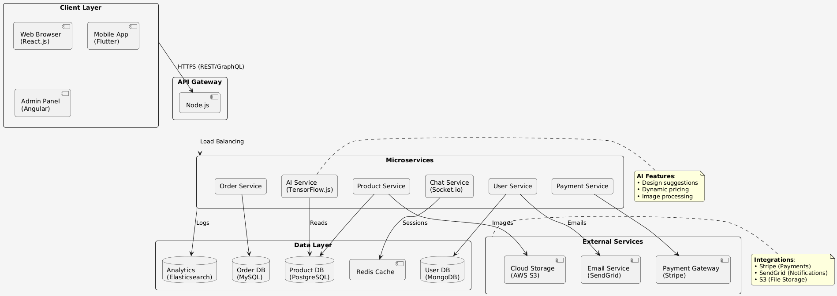

Application and Data Architecture
Component Diagram
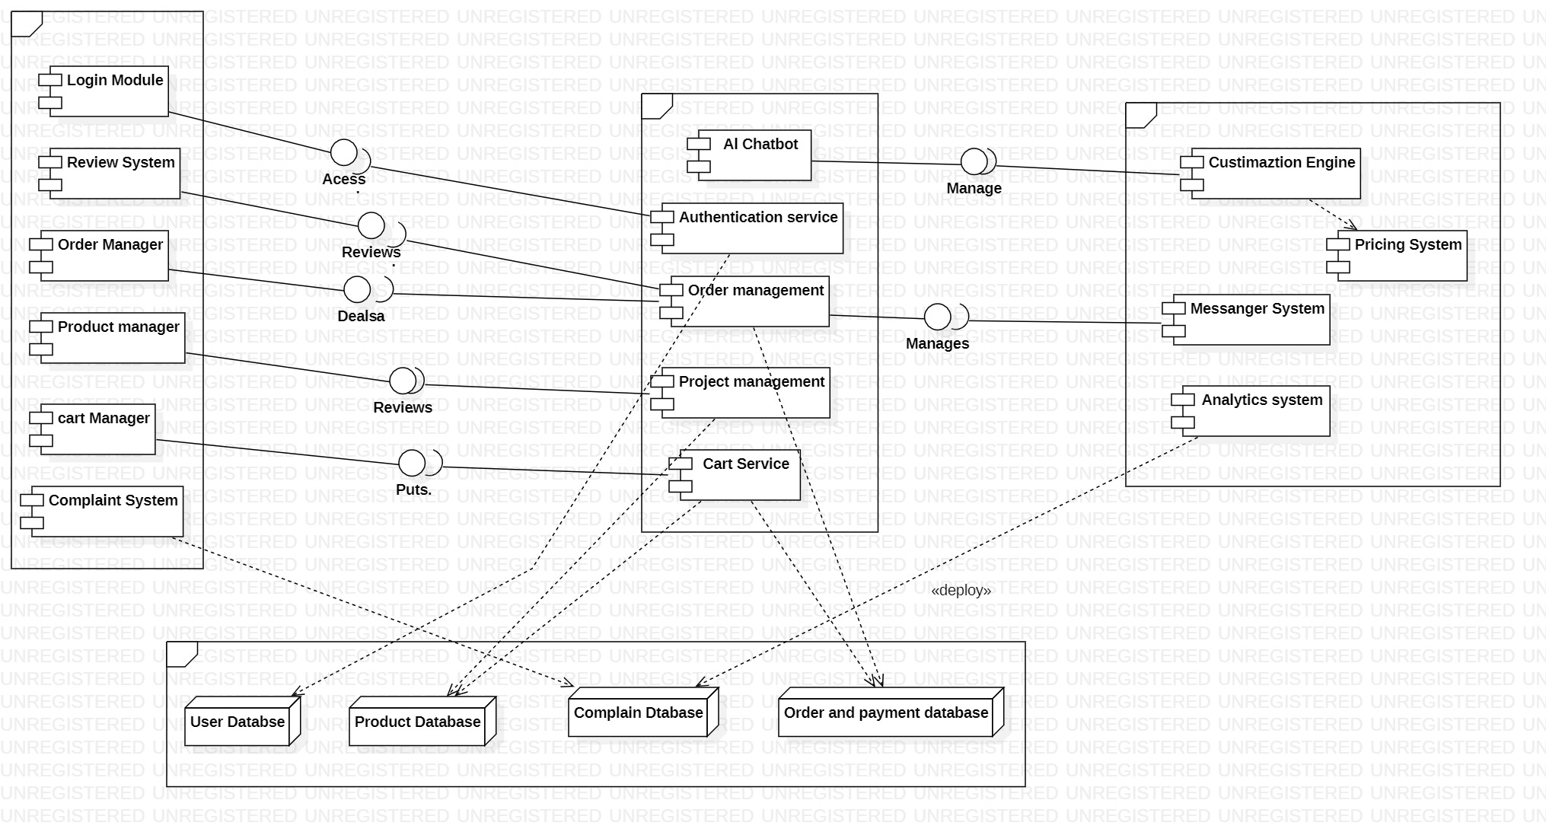

Class Diagram
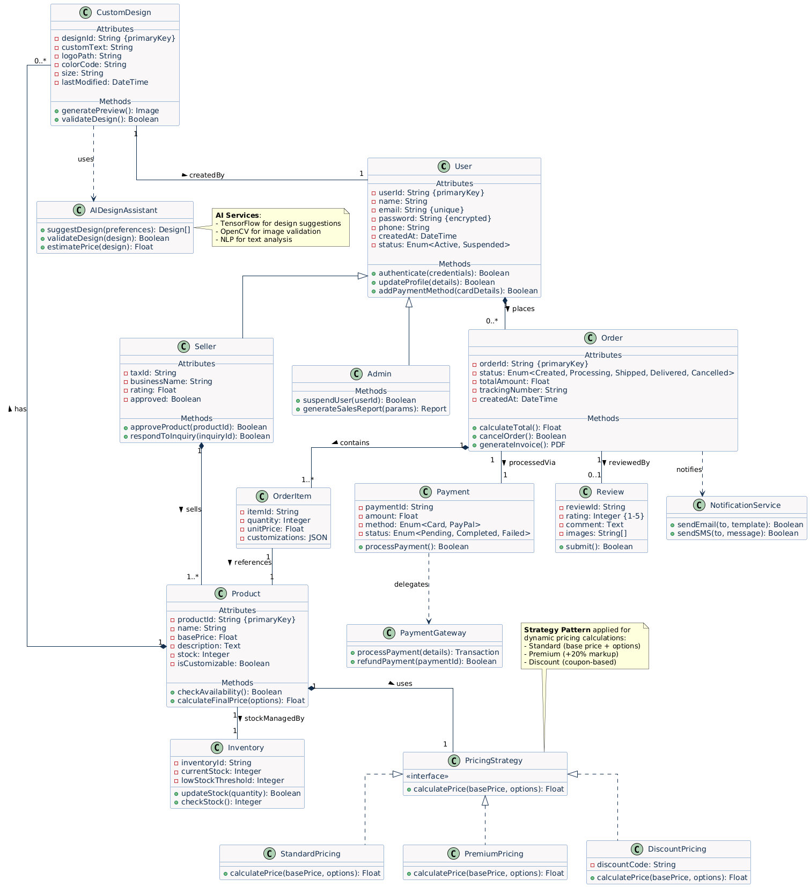
Erd Diagram
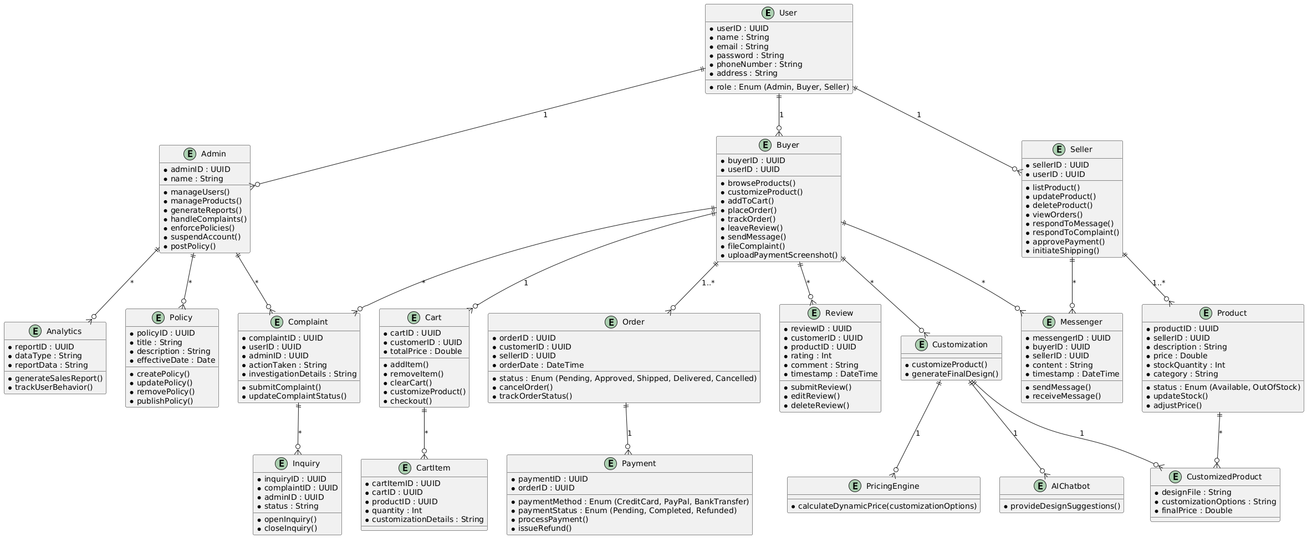

Activity Diagram for User
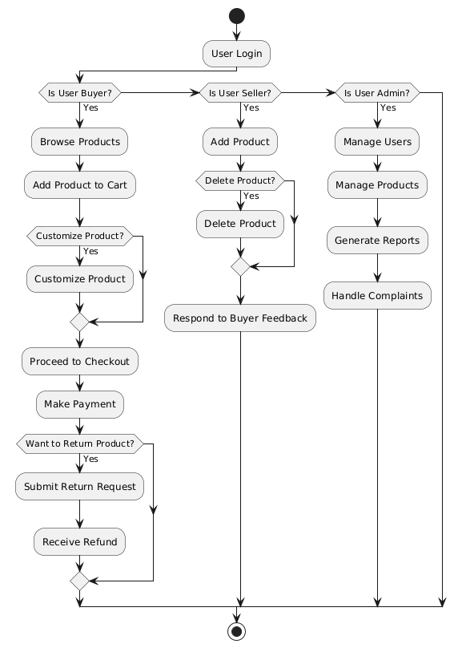

Activity Diagram for Seller
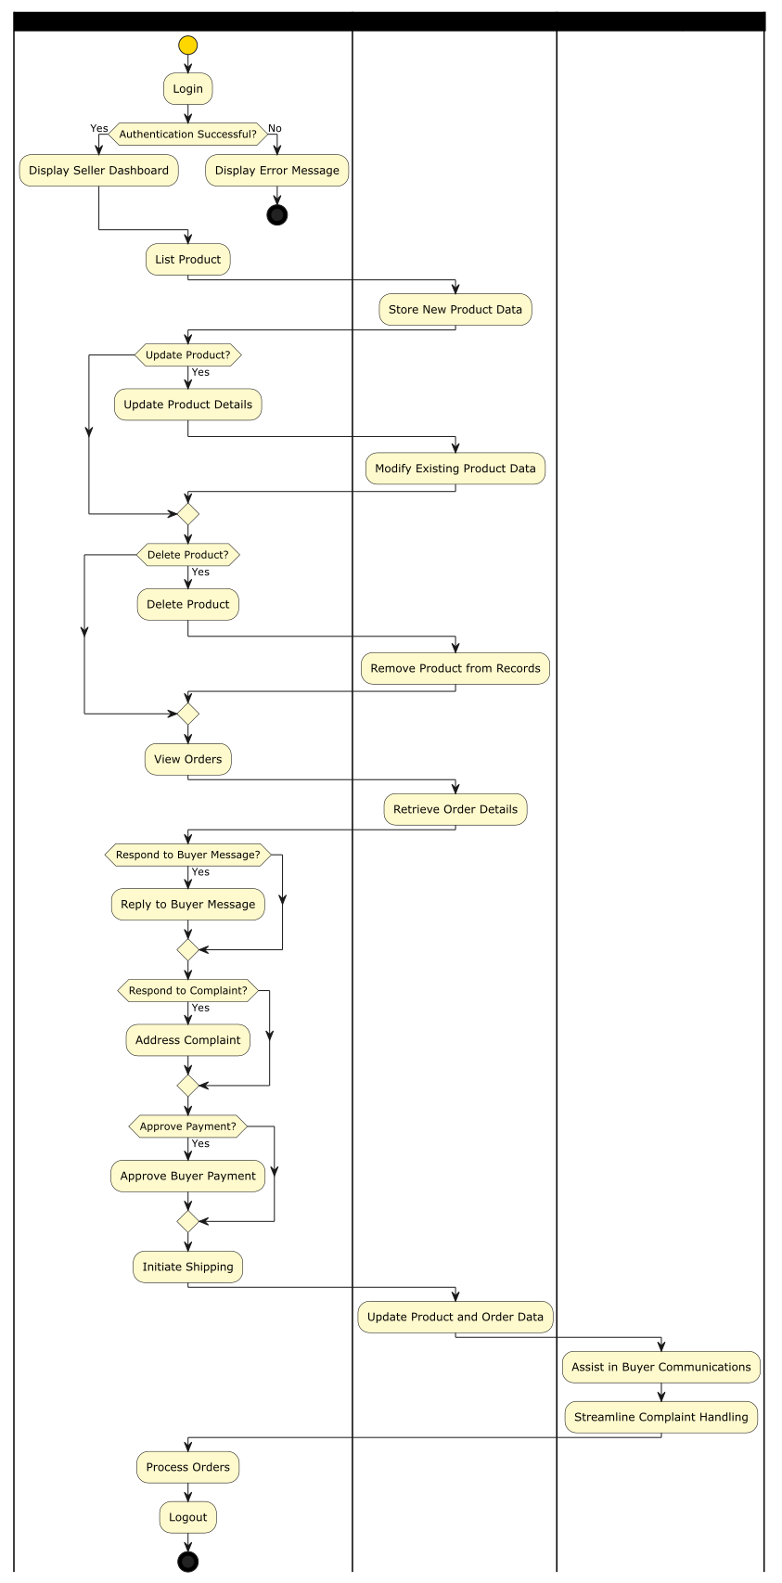

Sequence Diagram for Seller
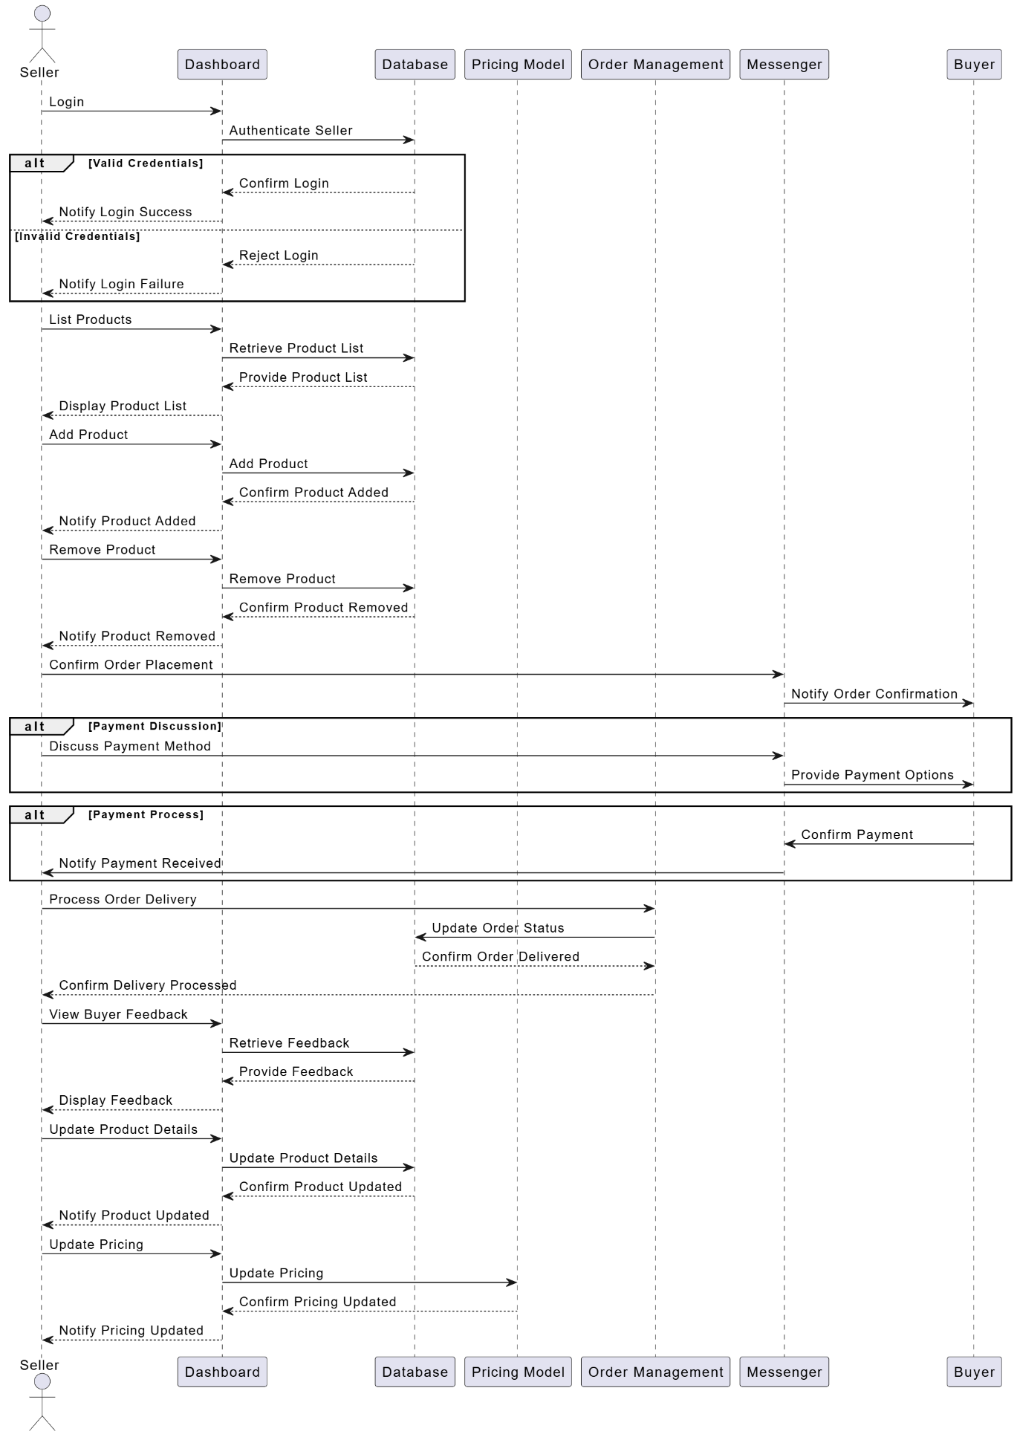

Sequence Diagram of Admin

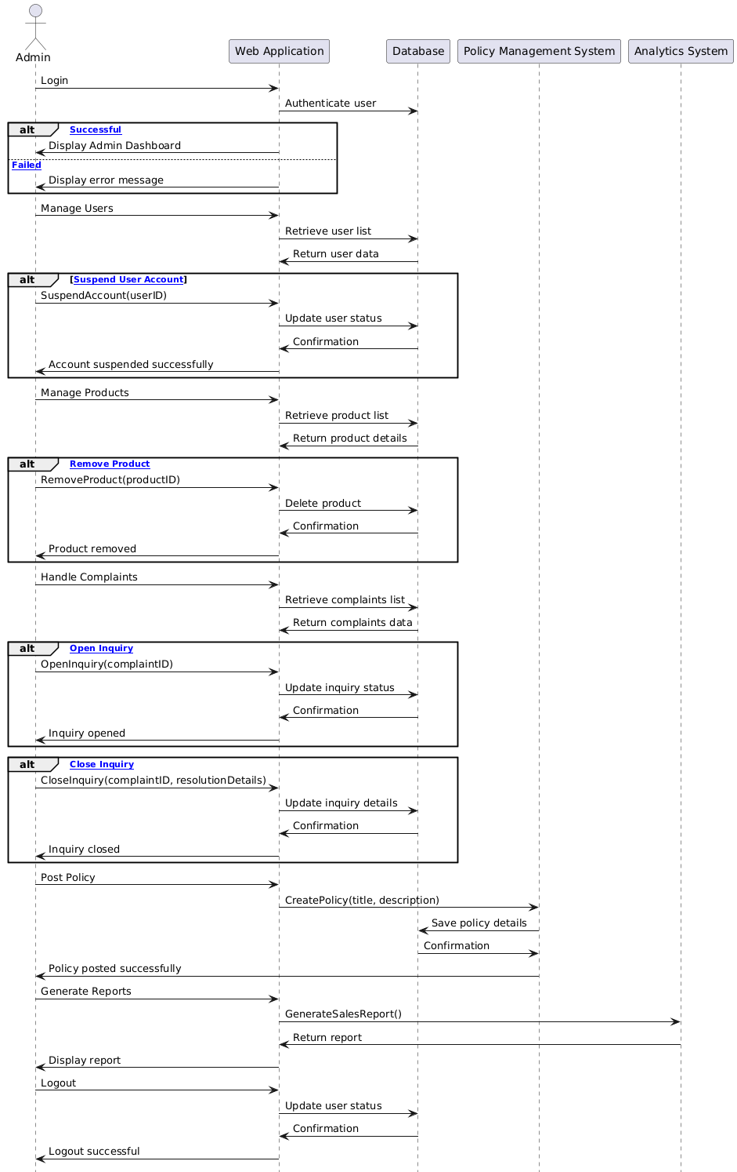

Component Interactions and Collaborations
Sequence Diagram order cancellation

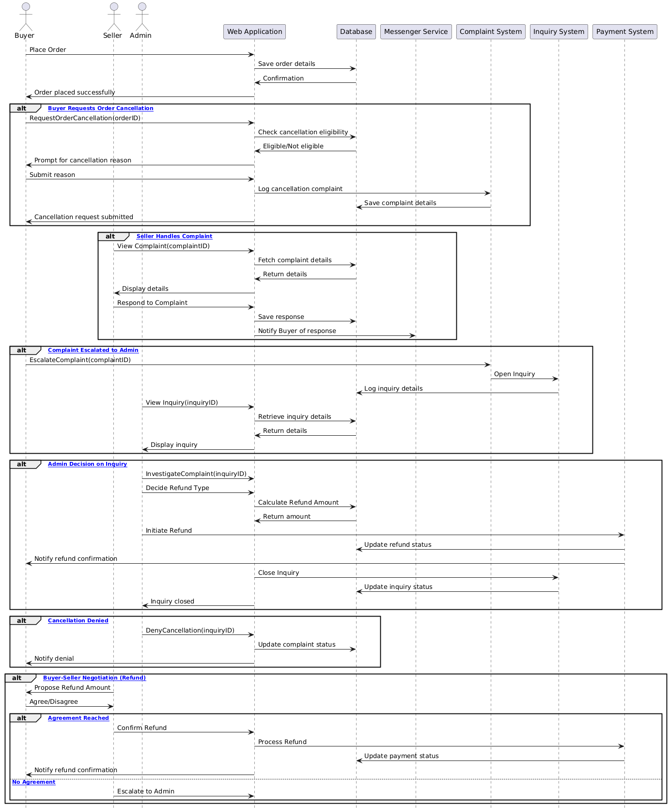

Dfd Diagram
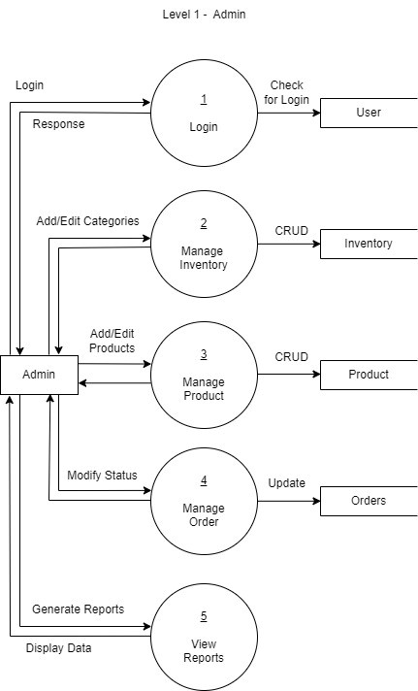

Dfd Diagram
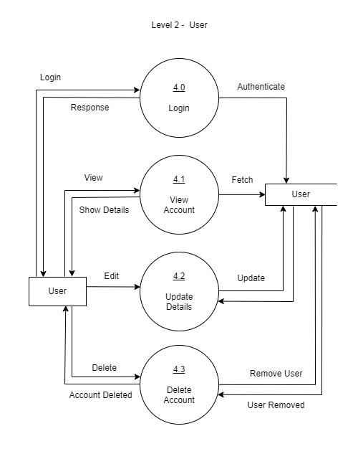
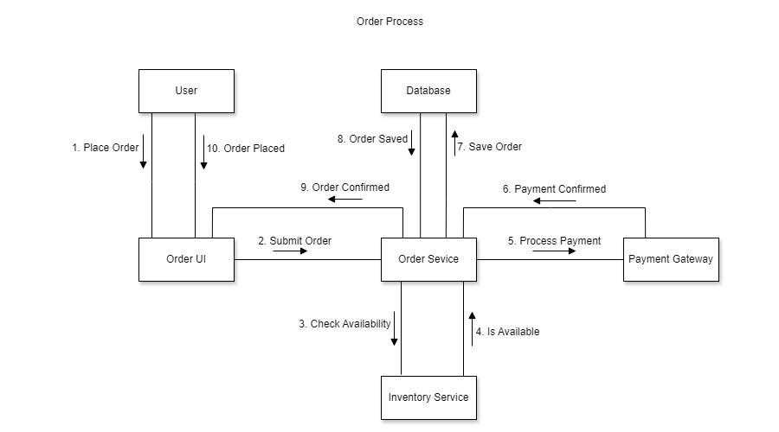

Event Traces
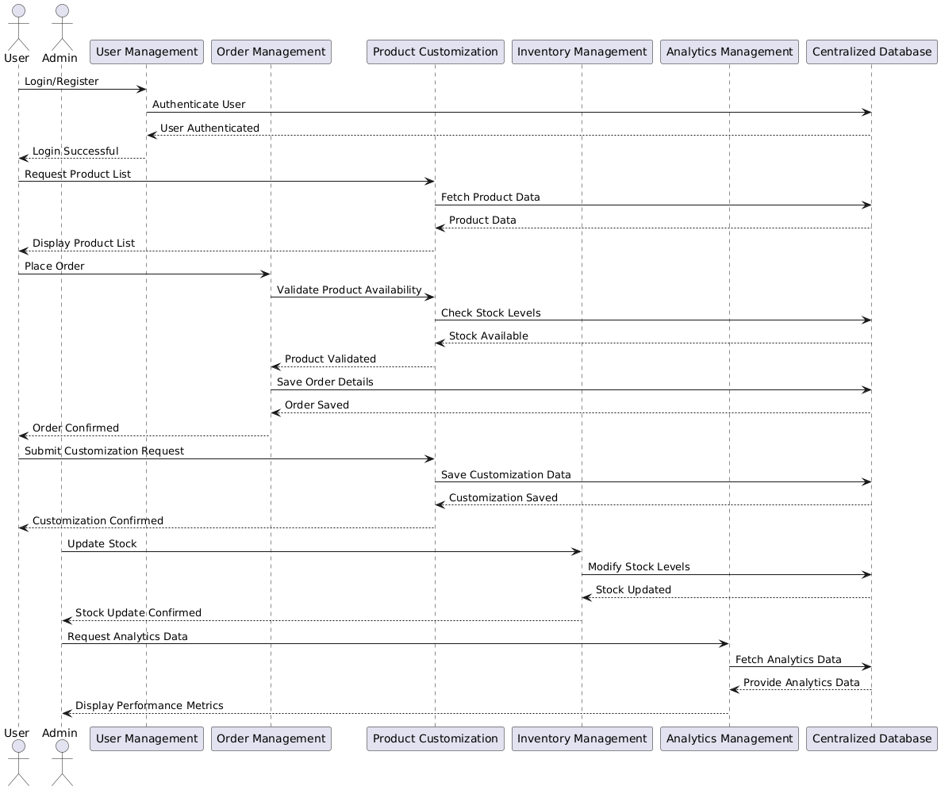

Design Reuse and Design Patterns
<State any reuse during development of the system>

Technology Architecture
The technology architecture of SportswearXpress is designed to support real-time interaction, AI-driven customization, and scalable e-commerce features. While cloud hosting is a common option, this project will be hosted on a non-cloud infrastructure, possibly on a university server or a local deployment setup for demonstration and testing purposes.

1. Platform
Frontend: Built using React.js, HTML5, CSS3, and JavaScript for a modern, responsive user interface accessible via web browsers.

Backend: Developed using Node.js with the Express.js framework, which provides fast, event-driven server operations ideal for handling user interactions and real-time updates.

AI Functionality: Powered by TensorFlow.js and OpenCV.js to deliver client-side AI recommendations for product customization without relying on cloud-based AI services.

2. System Hosting
Local Hosting / On-Premise Server:
The system will be hosted on a local server (e.g., a university-managed environment or standalone deployment on physical hardware).
This setup supports local access for development and testing.
Suitable for prototype or proof-of-concept phases.
Simplifies infrastructure management during early-stage development.

3. Connectivity Requirements
Stable Local Network / Internet: Required to facilitate:
User login and session management.
Real-time messaging between buyer and seller via Socket.io.
AI interaction through in-browser computation.
API Connections (Optional): If needed, payment gateways like Stripe or PayPal can be integrated through external APIs, even in local setups.

4. Modes of Operation

Buyer Interface: Provides a customization UI, AI assistant, cart, and order management.
Seller Interface: Enables product upload, order tracking, and buyer communication.
Admin Panel: Facilitates system governance, analytics access, and user control.

5. Security
Local SSL (if applicable): Self-signed certificates may be used for encrypted communication in a local/test environment.
User Authentication: Implemented using OAuth 2.0 or session-based security models.
Data Management: Managed via MongoDB, with local database storage and access control.

Architecture Evaluation
Component | Chosen Technology | Reason for Selection
Frontend | React.js | Offers a component-based architecture, excellent state management, and fast UI rendering.
Backend | Node.js with Express.js | Non-blocking I/O, high performance, scalable for handling multiple real-time requests.
Database | MongoDB | NoSQL flexibility for storing varied product and customization data structures.
AI Customization | TensorFlow.js, OpenCV.js | Enables AI in-browser with fast performance and seamless integration into frontend.
Real-time Messaging | Socket.io | Enables bidirectional real-time communication between users (buyers, sellers).
Version Control | Git & GitHub | Industry standard for collaboration, version tracking, and code review.
Hosting | AWS (EC2, S3) / Vercel | Scalable, secure cloud infrastructure with deployment automation.

Pros of Selected Technologies
- React.js: Fast rendering, reusable components, vibrant ecosystem (e.g., Redux, Hooks).
- Node.js + Express: Handles asynchronous operations well, wide support for middleware.
- MongoDB: Schema-less flexibility supports varied and dynamic product customization formats.
- TensorFlow.js: In-browser AI processing avoids latency of server-based AI.
- Socket.io: Reliable real-time data transmission for messaging and status updates.
- AWS/Vercel: Highly available, scalable, and globally distributed infrastructure.

Cons and Challenges
- Node.js: Callback-heavy nature may lead to messy code if not properly structured (mitigated using async/await).
- MongoDB: Lacks complex joins and transactions compared to relational databases.
- TensorFlow.js: May have performance limitations on low-end devices.
- Socket.io: Real-time implementation requires careful resource management and security handling.

Detailed Design and Implementation

Component-Component Interface

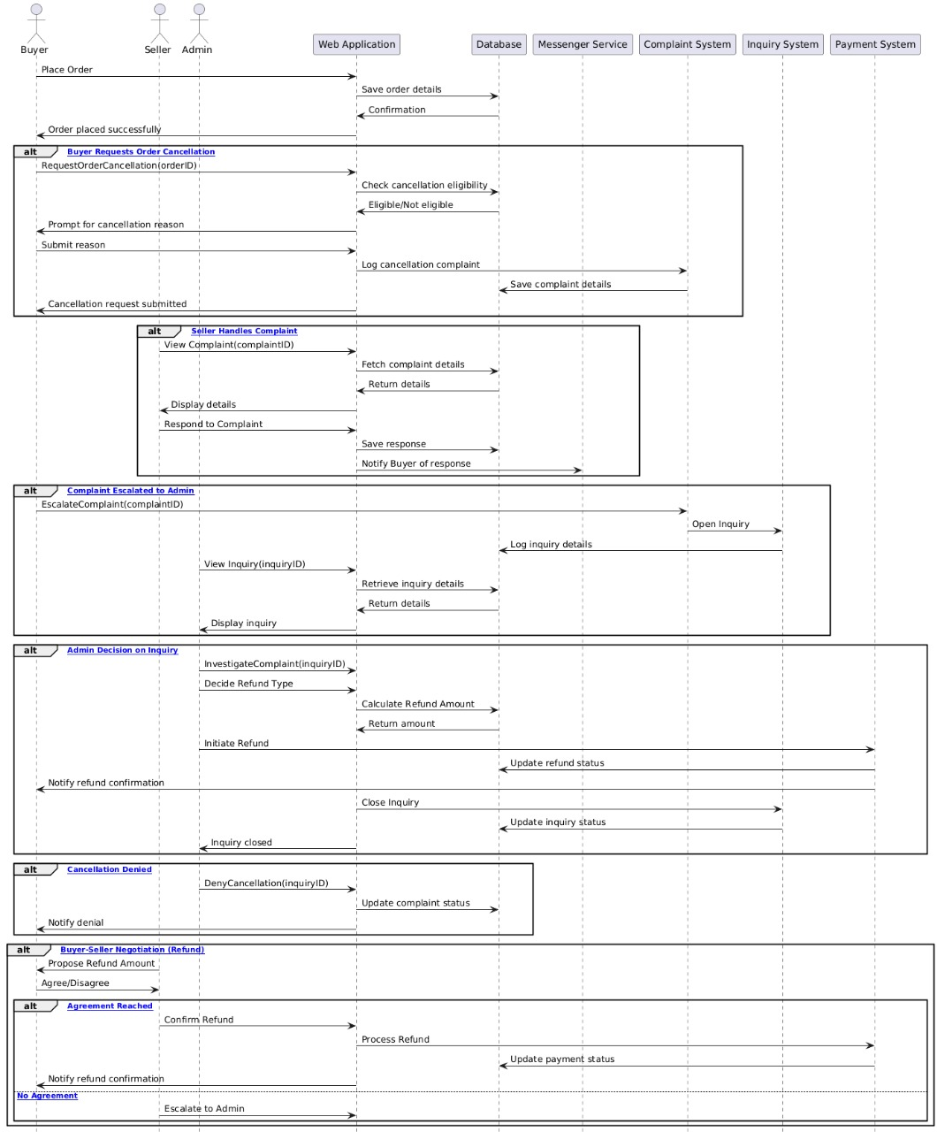

Component-External Entities Interface
Sign Up Page
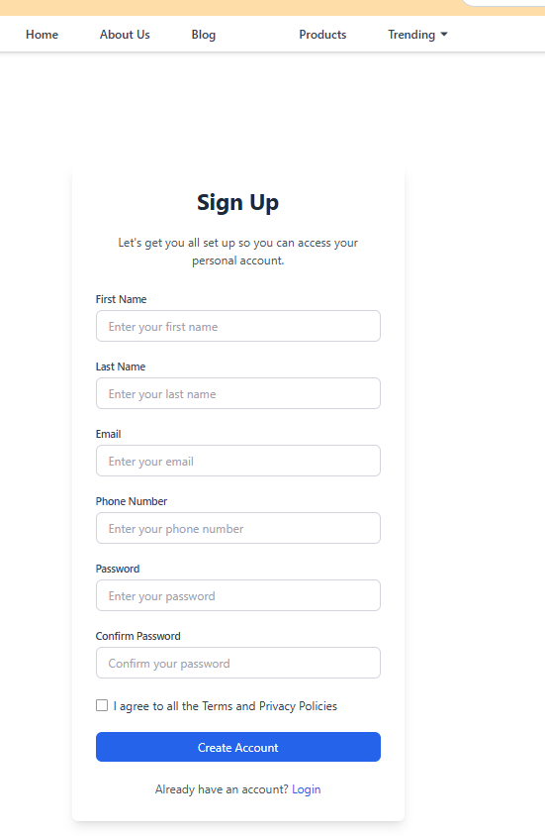

Add New Product

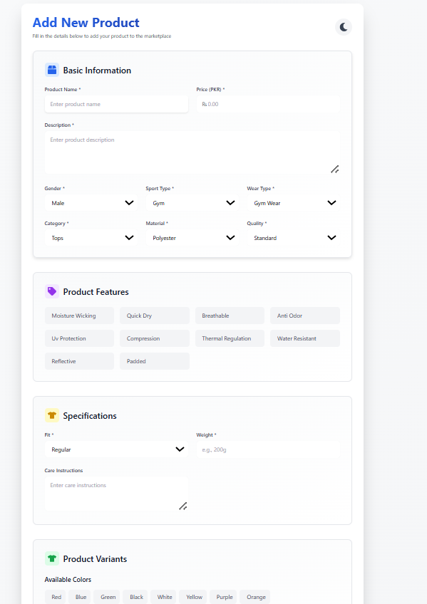

Component-Human Interface
SignIn Page:
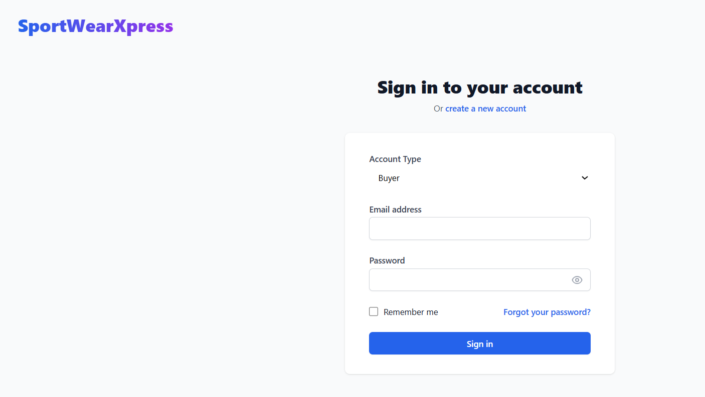

Checkout Page:
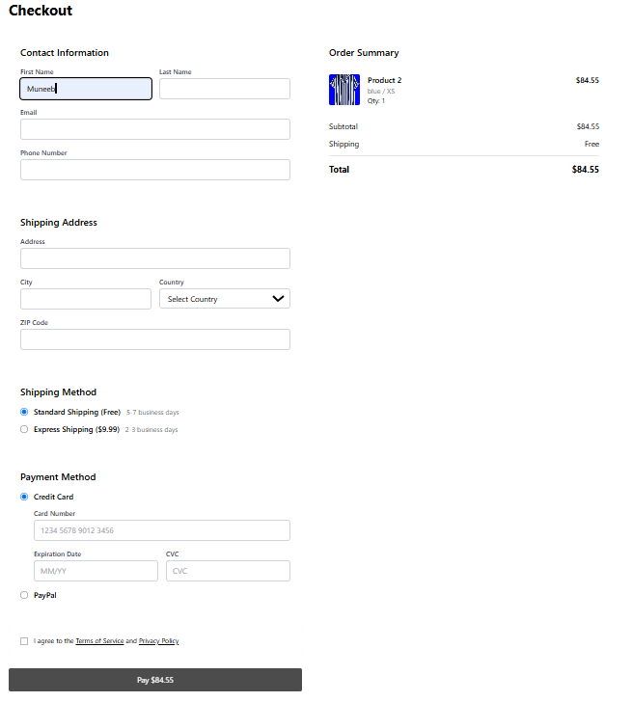

Screenshots/Prototype

Workflow
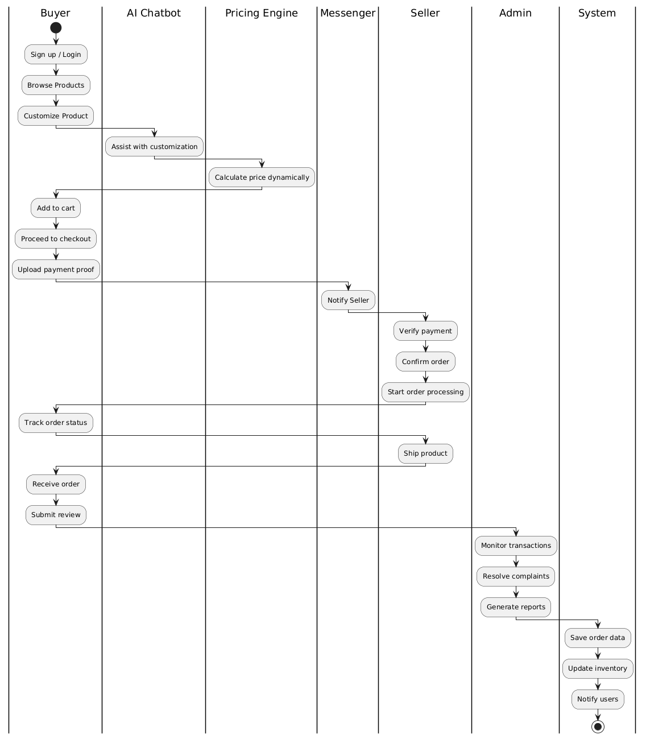

Screens
Dynamic Price Page

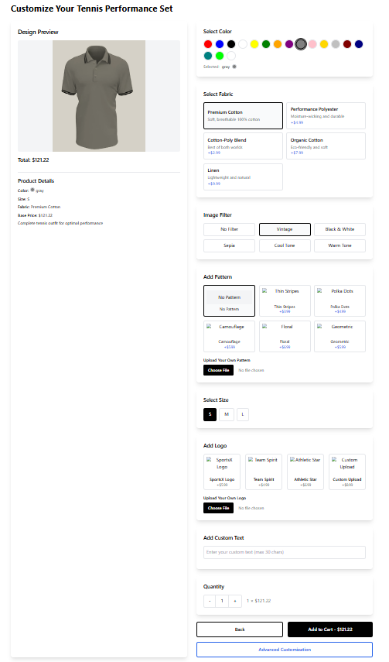

Advance customization Page

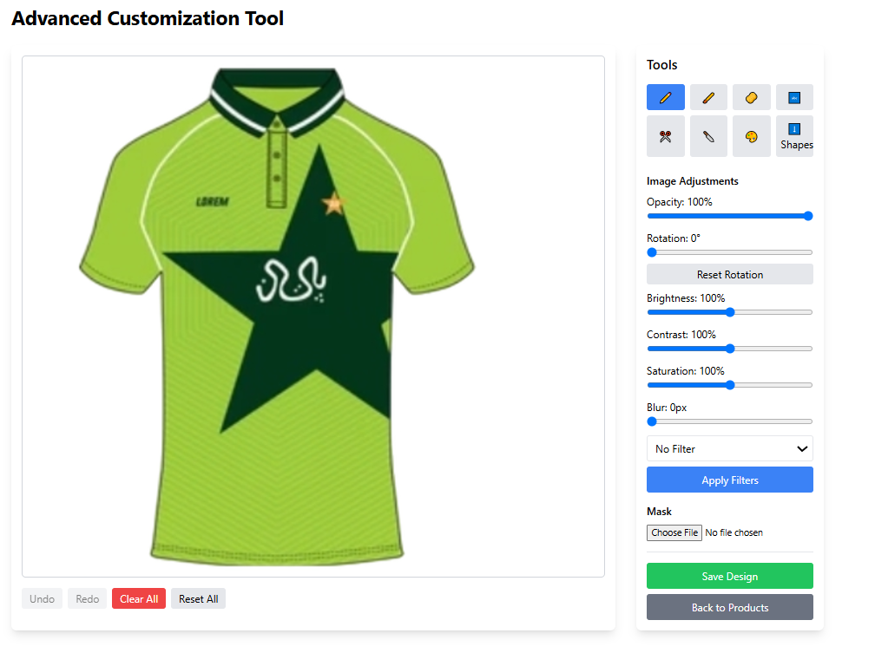

About us

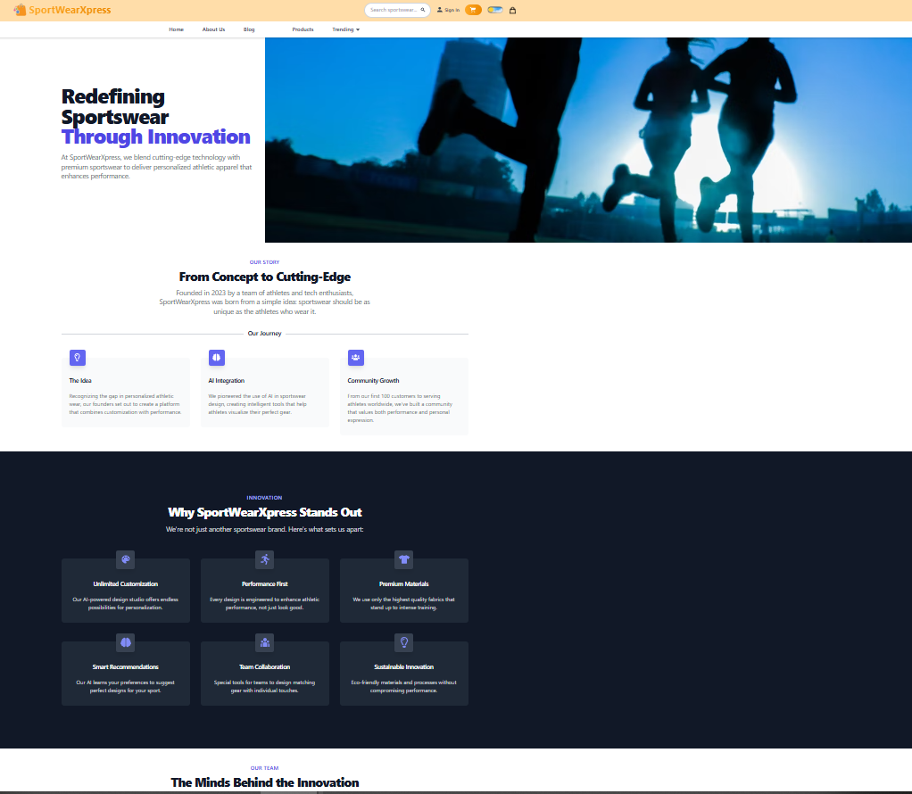

Blog Page
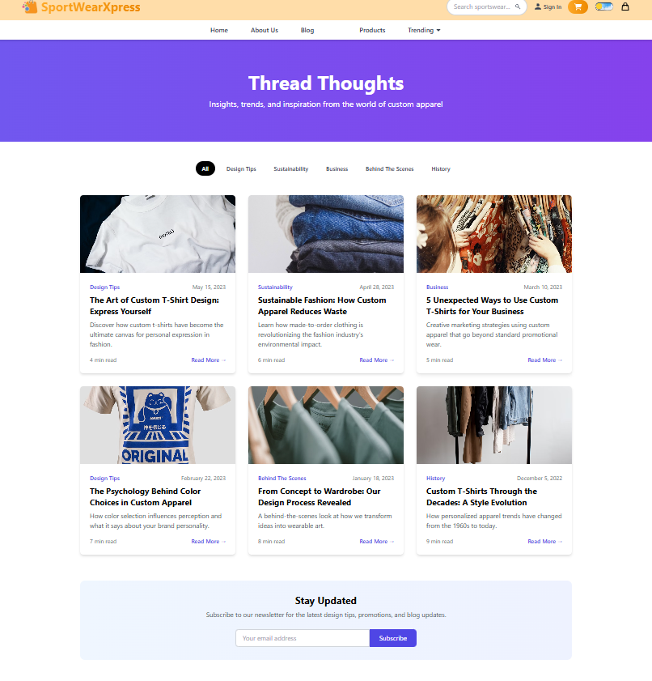

Product Details Page

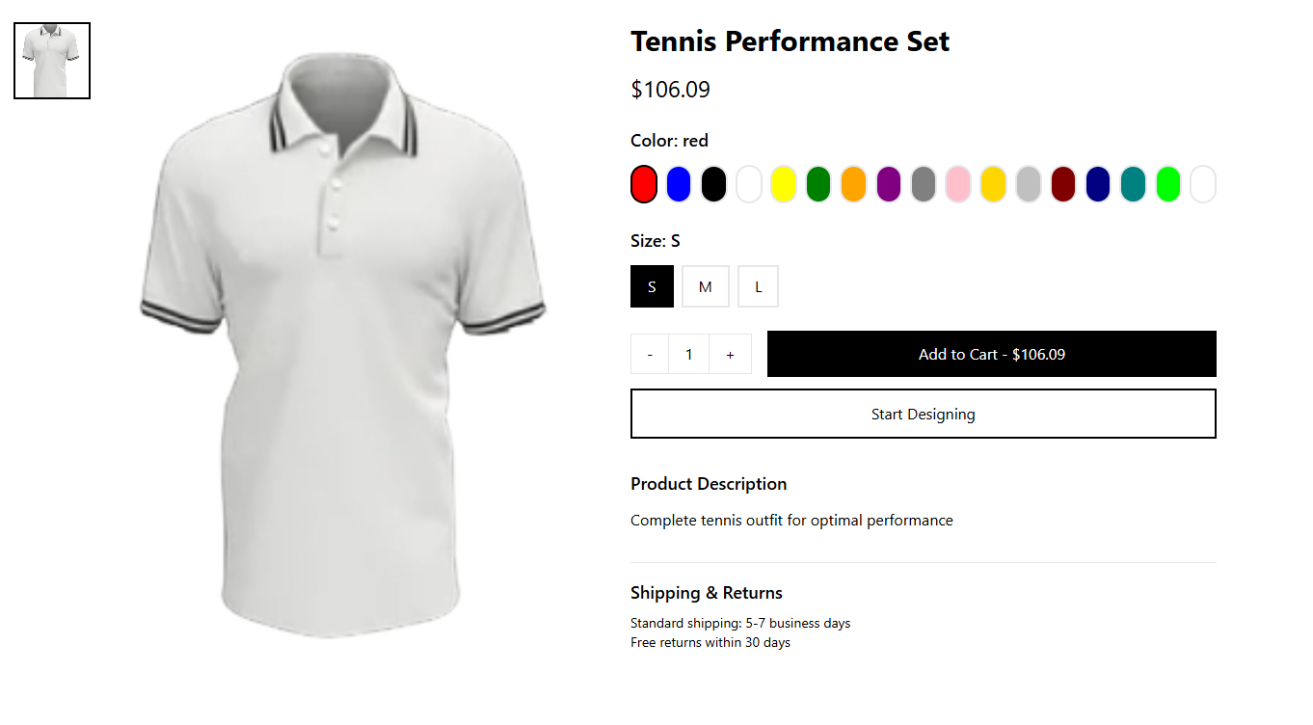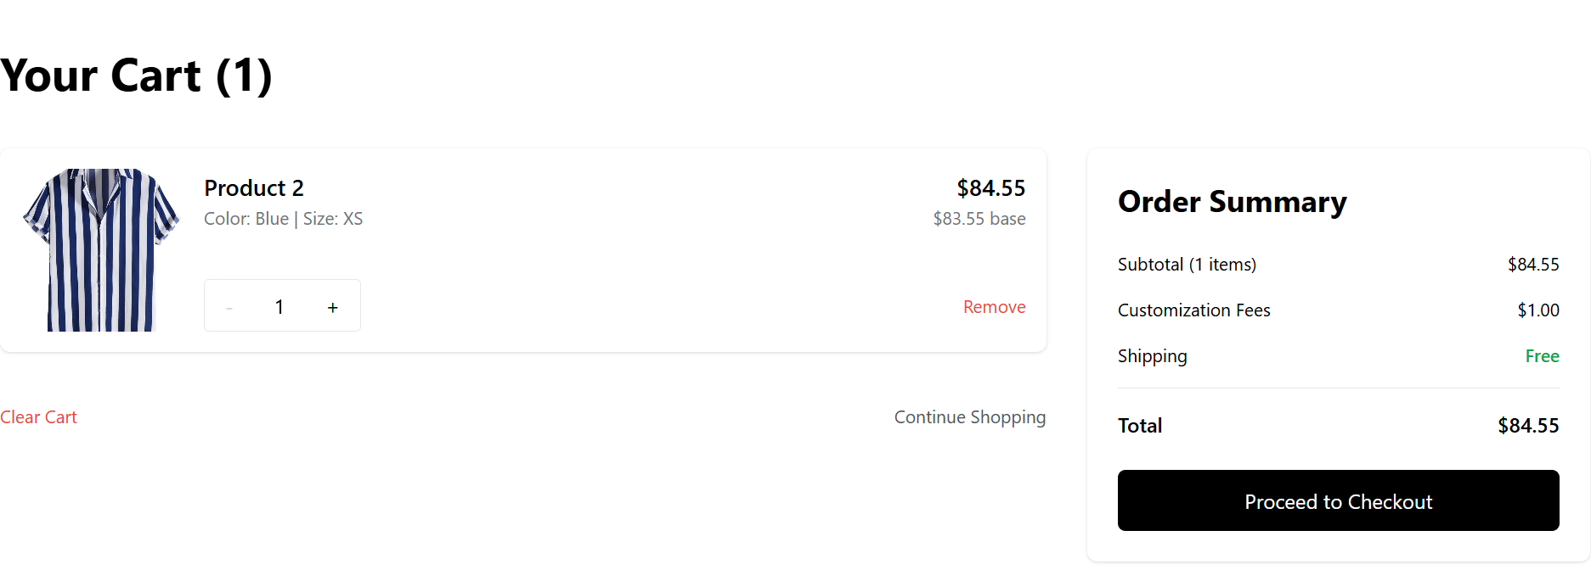

Checkout Page

Additional Information
Seller DashBoard

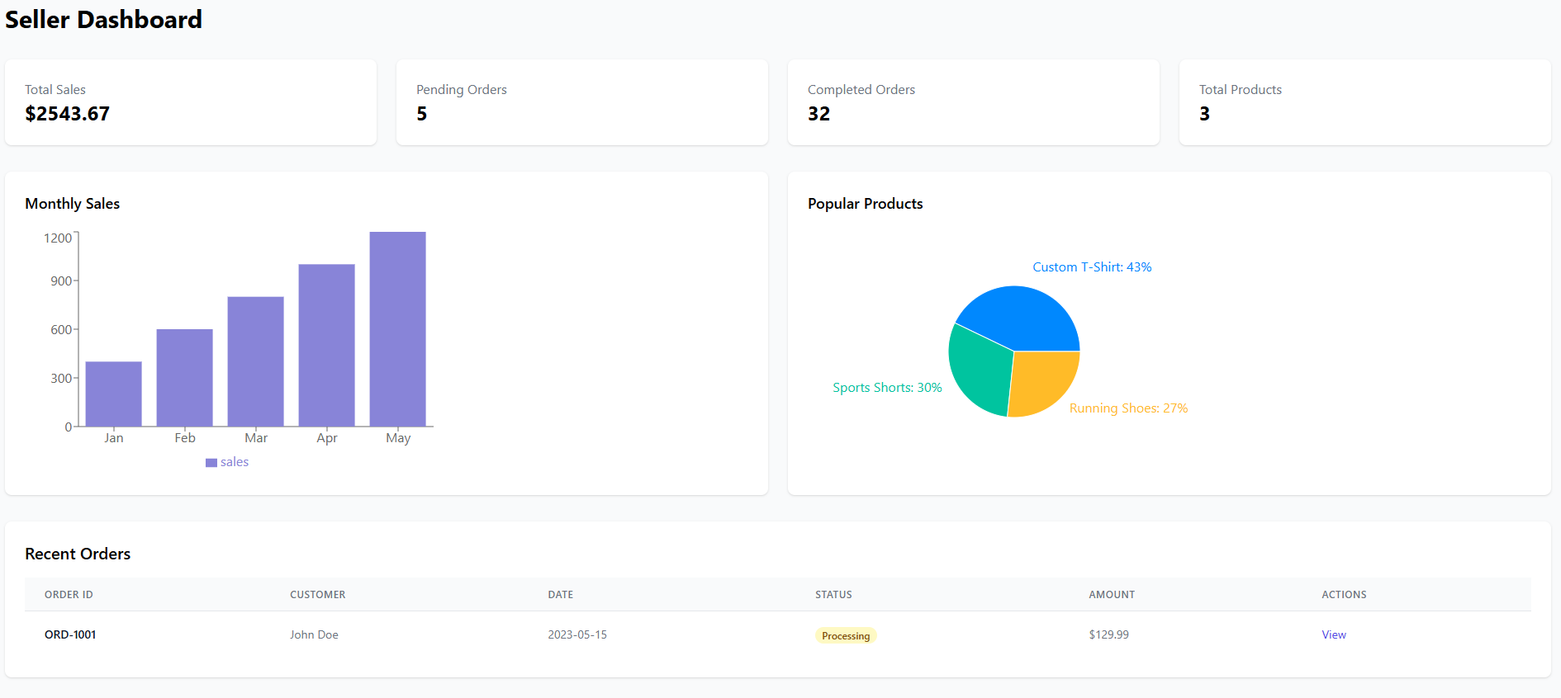

Other Design Details
Admin Dashboard
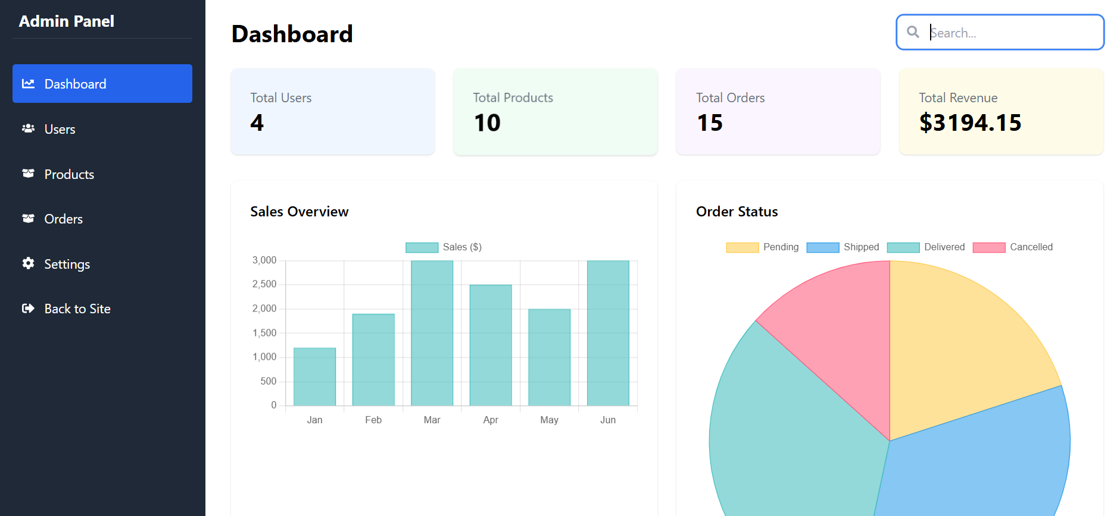

Verify Code

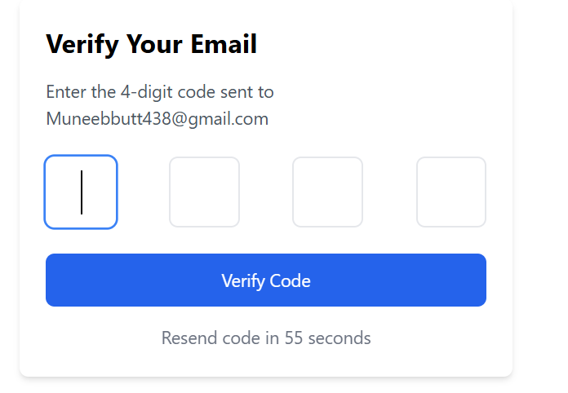

Forget Password
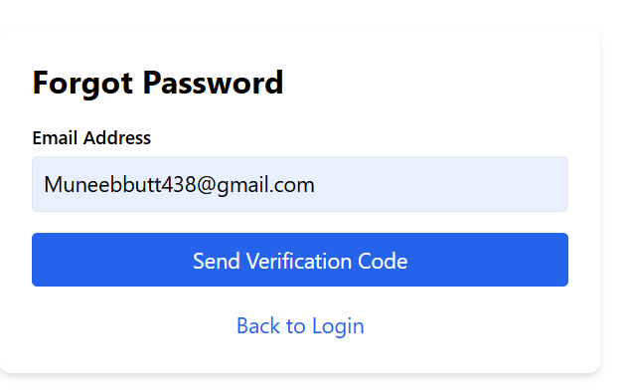

Test Specification and Results

Test Case Specification
Table 6.1: TC-1
Identifier | TC-1
Related requirements(s)
  Use Case: User Authentication and Profile Management (UC-1)
Short description
  Verify successful user login with valid credentials
Pre-condition(s)
  User has a registered account
Input data
  Email: validuser@example.com, Password: validPass123
Detailed steps
  1. Navigate to login page.
  2. Enter valid credentials.
  3. Click login button.
Expected result(s)
  User is successfully logged in and redirected to profile page
Post-condition(s)
  User session is created
Actual result(s) | Account is created
Test Case Result | pass
Table 6.2: TC-2
Identifier | TC-2
Related requirements(s)
  Use Case: User Authentication and Profile Management (UC-1)
Short description
  Verify login failure with wrong password
Pre-condition(s)
  User has a registered account
Input data
  Email: validuser@example.com, Password: wrongPass
Detailed steps
  1. Navigate to login page.
  2. Enter invalid credentials.
  3. Click login button.
Expected result(s)
  Error message "Incorrect credentials" displayed
Post-condition(s)
  User remains on login page
Actual result(s) | User remains on login page
Test Case Result | Pass
Table 6.3: TC-3
Identifier | TC-3
Related requirements(s)
  Use Case: Add to Cart (UC-2)
Short description
  Add an available item to cart
Pre-condition(s)
  Item is in stock, user logged in
Input data
  Item ID: 101, Quantity: 1
Detailed steps
  1. Select item.
  2. Click "Add to Cart".
Expected result(s)
  Item added to cart successfully
Post-condition(s)
  Cart updated
Actual result(s) | Product Add to cart
Test Case Result | Pass
Table 6.4: TC-4
Identifier | TC-4
Related requirements(s)
  Use Case: Add to Cart (UC-2)
Short description
  Attempt to add an out-of-stock item
Pre-condition(s)
  Item is out of stock
Input data
  Item ID: 102
Detailed steps
  1. Select item.
  2. Click "Add to Cart".
Expected result(s)
  Error message "Item out of stock"
Post-condition(s)
  No item added
Actual result(s) | Item is no added to cart
Test Case Result | Pass
Table 6.5: TC-5
Identifier | TC-5
Related requirements(s)
  Use Case: Product Customization (UC-3)
Short description
  Successfully customize a product
Pre-condition(s)
  User logged in, product supports customization
Input data
  Color: Red, Text: "Champion"
Detailed steps | 1. Open customization.  2. Set color and text.  3. Save.
Expected result(s)
  Customized product preview saved
Post-condition(s)
  Customized design linked
Actual result(s) | Product is successfully Customize
Test Case Result | Pass

Table 6.6: TC-6
Identifier | TC-6
Related requirements(s)
  Use Case: Product Customization (UC-3)
Short description
  Upload invalid file format during customization
Pre-condition(s)
  Customization tool open
Input data
  File format: .exe
Detailed steps
  1. Upload invalid file.
Expected result(s)
  Error "Invalid file format"
Post-condition(s)
  File not accepted
Actual result(s) | File has not been Accepted
Test Case Result | Pass
Table 6.7: TC-7
Identifier | TC-7
Related requirements(s)
  Use Case: Save Product Design (UC-4)
Short description
  Successfully save completed product design
Pre-condition(s)
  Design completed
Input data
  Design Name: "Summer Edition"
Detailed steps | 1. Complete design.  2. Click "Save Design".
Expected result(s)
  Design saved successfully
Post-condition(s)
  Design stored
Actual result(s) | Design have been saved
Test Case Result | Pass

Table 6.8: TC-8
Identifier | TC-8
Related requirements(s)
  Use Case: Save Product Design (UC-4)
Short description
  Save attempt without completing customization
Pre-condition(s)
  Incomplete design
Input data
  None
Detailed steps
  1. Open design.
  2. Click "Save" prematurely.
Expected result(s)
  Error "Customization incomplete"
Post-condition(s)
  No design saved
Actual result(s) | Design has not been Saved
Test Case Result | Pass

Table 6.9: TC-9
Identifier | TC-9
Related requirements(s)
  Use Case: Adjust Pricing (UC-5)
Short description
  Successfully apply a valid discount
Pre-condition(s)
  Admin logged in
Input data
  Discount: 15%
Detailed steps
  1. Select product.
  2. Apply 15% discount.
  3. Save changes.
Expected result(s)
  Discount applied successfully
Post-condition(s)
  New price displayed
Actual result(s) | New Price has been displayed
Test Case Result | Pass
Table 6.10: TC-10
Identifier | TC-10
Related requirements(s)
  Use Case: Adjust Pricing (UC-5)
Short description
  Attempt to set invalid discount below minimum
Pre-condition(s)
  Admin logged in
Input data
  New Price: 0
Detailed steps
  1. Select product.
  2. Set price to 0.
  3. Save changes.
Expected result(s)
  Error "Invalid price value"
Post-condition(s)
  Price remains unchanged
Actual result(s) | Price doesn’t change
Test Case Result | Pass

Table 6.11: TC-11
Identifier | TC-11
Related requirements(s)
  Use Case: Track Design Changes (UC-6)
Short description
  Track saved product design changes successfully
Pre-condition(s)
  Saved changes available
Input data
  Design ID: 001
Detailed steps
  1. Open saved designs.
  2. View change history.
Expected result(s)
  List of design changes displayed
Post-condition(s)
  Changes available for review
Actual result(s) | Track saved product design changes successfully
Test Case Result | Pass

Table 6.12: TC-12
Identifier | TC-12
Related requirements(s)
  Use Case: Track Design Changes (UC-6)
Short description
  Attempt to track changes without any saved designs
Pre-condition(s)
  No saved designs available
Input data
  -
Detailed steps
  1. Open track changes section.
Expected result(s)
  Error "No design changes available"
Post-condition(s)
  No change history shown
Actual result(s) | Error "No design changes available"
Test Case Result | Pass

Table 6.13: TC-13
Identifier | TC-13
Related requirements(s)
  Use Case: Place Order (UC-7)
Short description
  Successfully place an order
Pre-condition(s)
  Cart has at least one item
Input data
  Shipping address and payment info
Detailed steps
  1. Proceed to checkout.
  2. Enter shipping and payment.
  3. Confirm order.
Expected result(s)
  Order placed successfully with order ID generated
Post-condition(s)
  New order created
Actual result(s) | Order have been placed successfully and order ID is generated
Test Case Result | Pass

Table 6.14: TC-14
Identifier | TC-14
Related requirements(s)
  Use Case: Place Order (UC-7)
Short description
  Attempt to checkout with empty cart
Pre-condition(s)
  Cart is empty
Input data
  -
Detailed steps
  1. Proceed to checkout without adding any item.
Expected result(s)
  Error "Cart is empty"
Post-condition(s)
  No order placed
Actual result(s) | Cart is empty
Test Case Result | Pass

Table 6.15: TC-15
Identifier | TC-15
Related requirements(s)
  Use Case: Track Order (UC-8)
Short description
  Successfully track an existing order
Pre-condition(s)
  Order placed
Input data
  Order ID: 1234
Detailed steps
  1. Open "Track Order".
  2. Enter valid Order ID.
Expected result(s)
  Order status and tracking info displayed
Post-condition(s)
  Order information shown
Actual result(s) | Order information has been shown
Test Case Result | Pass

Table 6.16: TC-16
Identifier | TC-16
Related requirements(s)
  Use Case: Track Order (UC-8)
Short description
  Attempt to track an invalid/non-existent order
Pre-condition(s)
  No such order exists
Input data
  Invalid Order ID
Detailed steps
  1. Open "Track Order".
  2. Enter invalid ID.
Expected result(s)
  Error "Order not found"
Post-condition(s)
  No tracking shown
Actual result(s) | Order is not found
Test Case Result | Pass

Table 6.17: TC-17
Identifier | TC-17
Related requirements(s)
  Use Case: Interact with Seller (UC-9)
Short description
  Successfully send a message to seller
Pre-condition(s)
  Buyer logged in, seller messaging enabled
Input data
  Message: "Need size details"
Detailed steps
  1. Open seller chat.
  2. Type and send message.
Expected result(s)
  Message delivered successfully
Post-condition(s)
  Message received by seller
Actual result(s) | Message have been delivered successfully
Test Case Result | Pass

Table 6.18: TC-18
Identifier | TC-18
Related requirements(s)
  Use Case: Interact with Seller (UC-9)
Short description
  Failed to send message due to system error
Pre-condition(s)
  System issue
Input data
  Message
Detailed steps
  1. Open chat.
  2. Attempt to send message during outage.
Expected result(s)
  Error "Message could not be sent"
Post-condition(s)
  Message not delivered
Actual result(s) | Message could not be sent
Test Case Result | Pass
Table 6.19: TC-19
Identifier | TC-19
Related requirements(s)
  Use Case: Product Reviews and Ratings (UC-10)
Short description
  Successfully leave a review for a purchased product
Pre-condition(s)
  Product purchased
Input data
  Rating: 5 Stars, Review Text: "Excellent quality"
Detailed steps
  1. Select purchased product.
  2. Write review.
  3. Submit.
Expected result(s)
  Review saved and displayed
Post-condition(s)
  Review listed under product
Actual result(s)
  Review have been saved and displayed
Test Case Result | Pass

Table 6.20: TC-20
Identifier | TC-20
Related requirements(s)
  Use Case: Product Reviews and Ratings (UC-10)
Short description
  Attempt to review a non-purchased product
Pre-condition(s)
  No purchase record
Input data
  Review
Detailed steps
  1. Select product not bought.
  2. Try writing review.
Expected result(s)
  Error "Only purchased products can be reviewed"
Post-condition(s)
  No review submitted
Actual result(s) | Error "Only purchased products can be reviewed"
Test Case Result | Pass
Table 6.21: TC-21
Identifier | TC-21
Related requirements(s)
  Use Case: Analytics and Reporting (UC-11)
Short description
  Successfully view a sales report
Pre-condition(s)
  Admin logged in
Input data
  Report Type: Sales Report
Detailed steps
  1. Open Admin Dashboard.
  2. Click Analytics.
  3. Select "Sales Report".
Expected result(s)
  Sales report data displayed
Post-condition(s)
  Admin views report
Actual result(s) | Sales report data have been displayed
Test Case Result | Pass

Table 6.22: TC-22
Identifier | TC-22
Related requirements(s)
  Use Case: Analytics and Reporting (UC-11)
Short description
  Try viewing report with invalid date range
Pre-condition(s)
  Admin logged in
Input data
  Start Date: 01/01/2026, End Date: 01/01/2025
Detailed steps
  1. Open Analytics.
  2. Set invalid dates.
  3. Click Generate Report.
Expected result(s)
  Error "Invalid date range selected"
Post-condition(s)
  Report not generated
Actual result(s) | Invalid date range have been selected.Error!
Test Case Result | Pass

Table 6.23: TC-23
Identifier | TC-23
Related requirements(s)
  Use Case: Cancel Order (UC-12)
Short description
  Successfully cancel an order before shipping
Pre-condition(s)
  Order placed but not shipped
Input data
  Order ID: 5555
Detailed steps
  1. Open Orders.
  2. Select cancellable order.
  3. Click "Cancel Order".
Expected result(s)
  Order status changed to "Cancelled"
Post-condition(s)
  Order cancelled
Actual result(s) | Order have been Cancelled
Test Case Result | Pass

Table 6.24: TC-24
Identifier | TC-24
Related requirements(s)
  Use Case: Cancel Order (UC-12)
Short description
  Attempt to cancel a shipped order
Pre-condition(s)
  Order already shipped
Input data
  Order ID: 9999
Detailed steps
  1. Open Orders.
  2. Try cancelling a shipped order.
Expected result(s)
  Error "Order cannot be cancelled after shipping"
Post-condition(s)
  Order remains active
Actual result(s) | Order cannot be cancelled after shipping. Error!
Test Case Result | Pass

Table 6.25: TC-25
Identifier | TC-25
Related requirements(s)
  Use Case: Edit Profile (UC-13)
Short description
  Successfully edit profile with valid data
Pre-condition(s)
  User logged in
Input data
  New Email: user_new@example.com
Detailed steps | 1. Open Edit Profile.  2. Update email.  3. Save changes.
Expected result(s)
  Profile updated successfully
Post-condition(s)
  Updated user profile
Actual result(s)
Test Case Result | Pass

Table 6.26: TC-26
Identifier | TC-26
Related requirements(s)
  Use Case: Edit Profile (UC-13)
Short description
  Attempt to save profile with invalid email
Pre-condition(s)
  User logged in
Input data
  Email: invalidemail.com
Detailed steps
  1. Open Edit Profile.
  2. Enter invalid email.
  3. Save.
Expected result(s)
  Error "Invalid email format"
Post-condition(s)
  Profile not updated
Actual result(s) | email format Is Invalid
Test Case Result | Pass

Table 6.27: TC-27
Identifier | TC-27
Related requirements(s)
  Use Case: Remove From Cart (UC-14)
Short description
  Successfully remove item from cart
Pre-condition(s)
  Cart contains items
Input data
  Item ID: 4567
Detailed steps
  1. Open Cart.
  2. Click "Remove" next to item.
Expected result(s)
  Item removed from cart
Post-condition(s)
  Cart updated
Actual result(s) | Item have been removed from cart
Test Case Result | Pass

Table 6.28: TC-28
Identifier | TC-28
Related requirements(s)
  Use Case: Remove From Cart (UC-14)
Short description
  Attempt to remove from empty cart
Pre-condition(s)
  Cart empty
Input data
Detailed steps
  1. Open Cart.
  2. Try removing any item.
Expected result(s)
  Error "Your cart is empty"
Post-condition(s)
  No change
Actual result(s) | Your cart is empty. Error!
Test Case Result | Pass

Table 6.29: TC-29
Identifier | TC-29
Related requirements(s)
  Use Case: Create Profile (UC-15)
Short description
  Successfully create a new user profile
Pre-condition(s)
  User not registered
Input data
  Name: Sarah Khan, Email: sarahkhan@example.com, Password: SafePass123
Detailed steps
  1. Open Sign Up.
  2. Enter valid details.
  3. Submit form.
Expected result(s)
  Profile created successfully
Post-condition(s)
  User registered and logged in
Actual result(s) | new user profile have been created
Test Case Result | Pass

Table 6.30: TC-30
Identifier | TC-30
Related requirements(s)
  Use Case: Create Profile (UC-15)
Short description
  Attempt to create profile with duplicate email
Pre-condition(s)
  Email already registered
Input data
  Email: alreadyregistered@example.com
Detailed steps
  1. Open Sign Up.
  2. Enter duplicate email.
  3. Submit form.
Expected result(s)
  Error "Email already in use"
Post-condition(s)
  No new account created
Actual result(s) | Email already in use. Error!
Test Case Result | Pass
Table 6.31: TC-31
Identifier | TC-31
Related requirements(s)
  Use Case: Send Refund (UC-16)
Short description
  Successfully issue a refund for eligible order
Pre-condition(s)
  Order eligible for refund
Input data
  Order ID: 3333, Refund Amount: PKR 5000
Detailed steps
  1. Open Refund Section.
  2. Select eligible order.
  3. Confirm refund.
Expected result(s)
  Refund processed successfully
Post-condition(s)
  Refund status updated
Actual result(s) | issue have been refund for eligible order
Test Case Result | Pass

Table 6.32: TC-32
Identifier | TC-32
Related requirements(s)
  Use Case: Send Refund (UC-16)
Short description
  Attempt to issue refund for ineligible order
Pre-condition(s)
  Order not eligible for refund
Input data
  Order ID: 7777
Detailed steps
  1. Open Refund Section.
  2. Select ineligible order.
  3. Try confirming refund.
Expected result(s)
  Error "Refund not applicable for this order"
Post-condition(s)
  No refund processed
Actual result(s) | Refund is not applicable for this order
Test Case Result | Pass

Summary of Test Results
Table 6.2: Summary of Test Results
Module Name | Test cases run | Number of defects found | Number of defects corrected so far | Number of defects still need to be corrected
User Authentication and Profile Management | TC-1, TC-2 | 1 | 1 | 0
Add to Cart | TC-3, TC-4 | 1 | 1 | 0
Product  Customization | TC-5, TC-6 | 1 | 1 | 0
Save Product Design | TC-7, TC-8 | 1 | 1 | 0
Adjust Pricing | TC-9, TC-10 | 1 | 1 | 0
Track Design Changes | TC-11, TC-12 | 1 | 1 | 0
Place Order | TC-13, TC-14 | 1 | 1 | 0
Track Order | TC-15, TC-16 | 1 | 1 | 0
Interact with Seller | TC-17, TC-18 | 1 | 1 | 0
Product Reviews and Ratings | TC-19, TC-20 | 1 | 1 | 0
Analytics and Reporting | TC-21, TC-22 | 1 | 1 | 0
Cancel Order | TC-23, TC-24 | 1 | 1 | 0
Edit Profile | TC-25, TC-26 | 1 | 1 | 0
Remove From Cart | TC-27, TC-28 | 1 | 1 | 0
Create Profile | TC-29, TC-30 | 1 | 1 | 0
Send Refund | TC-31, TC-32 | 1 | 1 | 0
Complete System | TC-1 to TC-32 | 16 | 16 | 0

Project Completion Status/Conclusion
Table 7.1: Project Completion Status

Module Name | Status  (Complete, Partially Implemented, Not Implemented)
Module 1: User Authentication & Profile Management | Complete
Module 2: Add to Cart | Complete
Module 3: Product Customization | Complete
Module 4: Save Product Design | Complete
Module 5: Adjust Pricing | Complete
Module 6: Track Design Changes | Complete
Module 7: Place Order | Complete
Module 8: Track Order | Complete
Module 9: Interact with Seller (Messenger) | Complete
Module 10: Product Reviews and Ratings | Complete
Module 11: Analytics and Reporting | Complete
Module 12: Cancel Order | Complete
Module 13: Edit Profile | Complete
Module 14: Remove from Cart | Complete
Module 15: Create Profile | Complete
Module 16: Send Refund | Complete
Complete System | Completed
Table 7.2: Objective(s)/Target(s) Status
Target/Objective | Status  (Completed,  Partially Completed,  Not Completed) | Reason(s)
Objective 1
Objective 2 | …
… | …
Number of Targets Completed | …
Number of Targets Partially Completed
Number of Targets Not Completed

References
[1] Zazzle, “Zazzle - Customize Anything,” [Online]. Available: https://www.zazzle.com/. [Accessed: 26-
Nov-2024].
[2] Custom Ink, “Custom Ink - Custom T-shirts and More,” [Online]. Available:
https://www.customink.com/. [Accessed: 26-Nov-2024].

Appendix A Glossary
Terms | Definition
AI | Artificial Intelligence
API | Application Programming Interface
AR | Augmented Reality
DB | Database
UI | User Interface
UX | User Experience
SDS | Software Design Specification
NLP | Natural Language Processing
IDE | Integrated Development Environment
AWS | Amazon Web Services
EC2 | Elastic Compute Cloud
S3 | Simple Storage Service
SQL | Structured Query Language
Appendix B IV & V Report
(Independent verification & validation)
IV & V Resource

Name Signature

S# | Defect Description | Origin Stage | Status | Fix Time
 |  |  |  | Hours | Minutes
1
2
3
…
Table B.1: List of non-trivial defects

Deployment/Installation Guide

Prerequisites
Before starting the setup, ensure the following software is installed on your system:
- Node.js (version 18 or above)
- npm (Node Package Manager)
- MongoDB (can be local or cloud-based like MongoDB Atlas)
- Git (optional, for cloning repositories)

Backend Installation (Node.js, Express, MongoDB)
- Navigate to the backend folder of the project.
- Install all required backend dependencies using npm. The main backend libraries used include:
- express
- mongoose
- dotenv
- jsonwebtoken
- bcryptjs
- cors
- multer
- express-rate-limit
- express-fileupload
- ua-parser-js
- Create a .env file inside the backend folder and add the following environment variables:
  - PORT=5000
  - MONGO_URI=mongodb://localhost:27017/yourdbname
  - JWT_SECRET=your_jwt_secret_key
- Start the backend server using the script:
  - For development: npm run dev
  - For production: npm start
- Once started, the backend API will be accessible at http://localhost:5000.

Frontend Installation (React, Vite, Tailwind CSS)
- Navigate to the frontend folder of the project.
- Install all required frontend dependencies using npm. The main frontend libraries used include:
- react and react-dom
- react-router-dom
- axios
- redux toolkit
- tailwindcss
- react-toastify
- framer-motion
- chart.js and react-chartjs-2
- firebase
- sweetalert2
- aos, slick-carousel, react-slick
- and other UI libraries
- Create a .env file inside the frontend folder and add the following variable:
  - VITE_API_BASE_URL=http://localhost:5000
- Start the frontend development server using the command: npm run dev.
- Once started, the frontend will be available at http://localhost:5173.

Deployment Suggestions (Optional)
For deploying the project in a production environment:
- Frontend Deployment Platforms: Vercel, Netlify
- Backend Deployment Platforms: Render, Railway, or Heroku
- Database Hosting: MongoDB Atlas
Make sure to:
- Replace local URLs in .env files with production URLs.
- Enable CORS for your deployed frontend URL in the backend.
- Use secure environment variables in each hosting platform.

Final Notes
- Ensure MongoDB is running before starting the backend.
- Always keep sensitive keys (like JWT secret and DB URI) in environment variables.
- If using cloud services, configure your deployment settings accordingly.

User Manual

Seller Side:

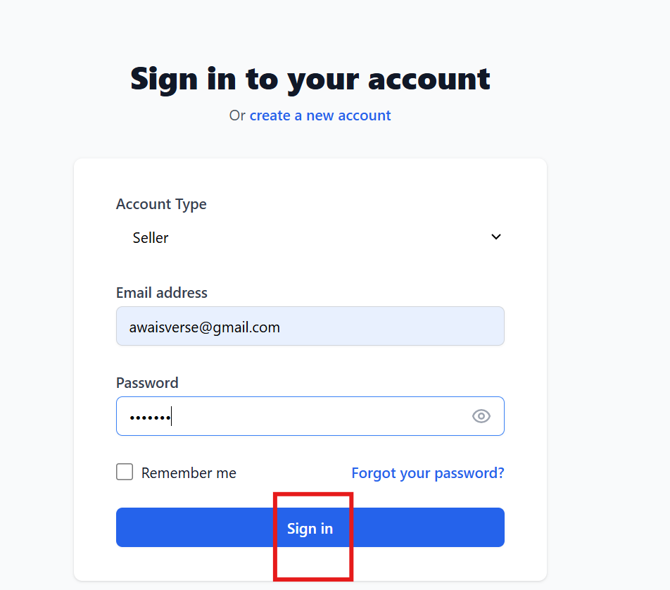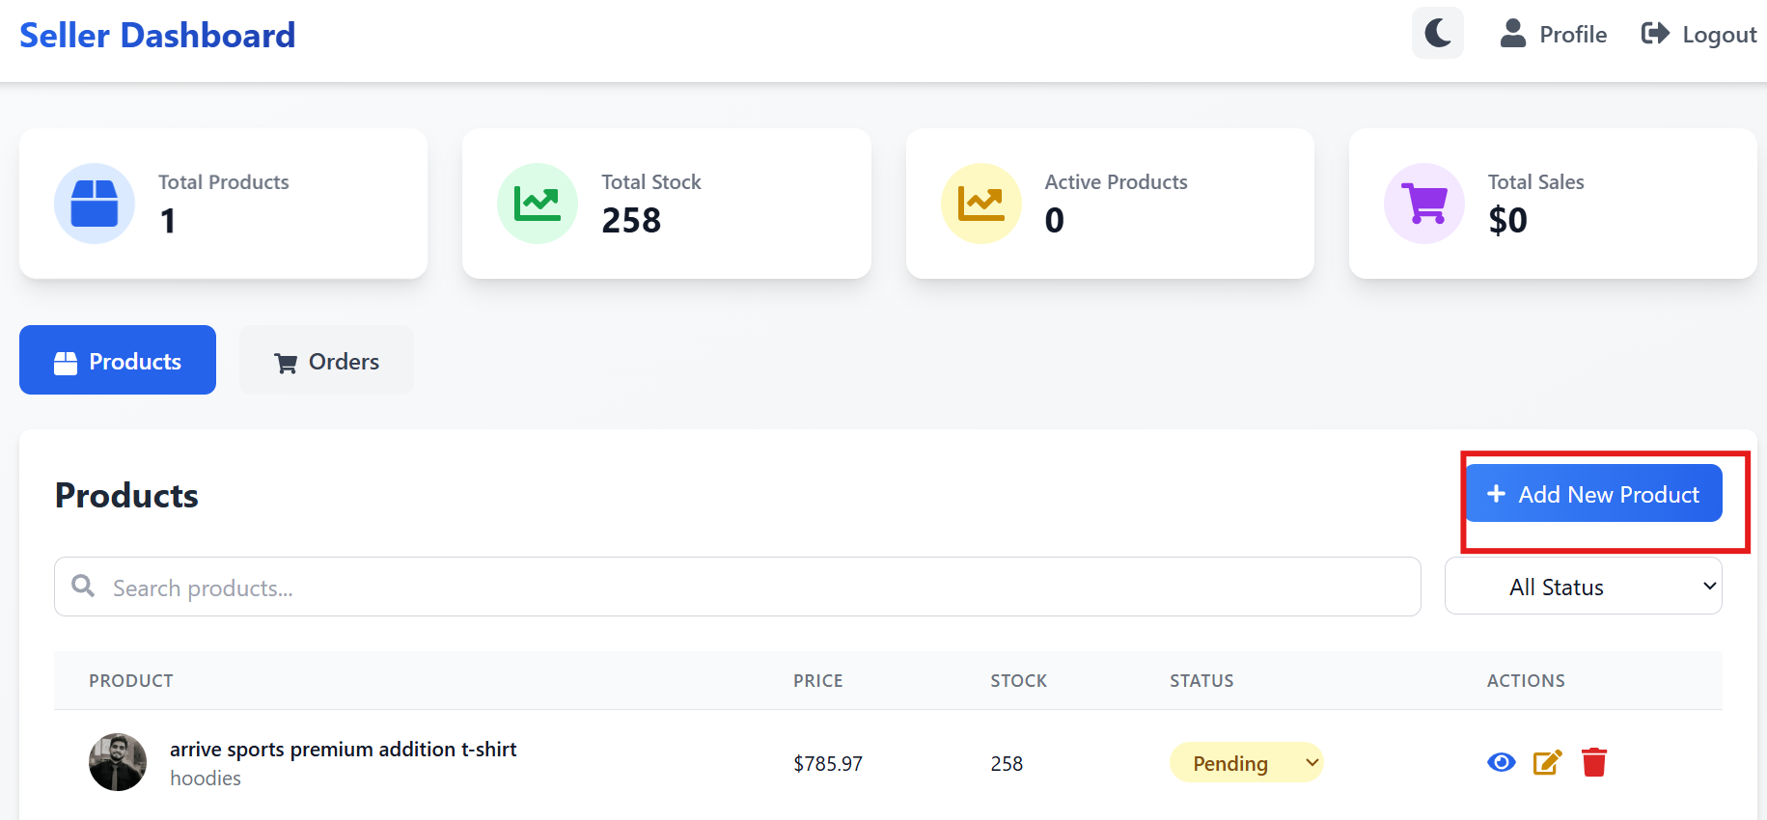

Admin Side:
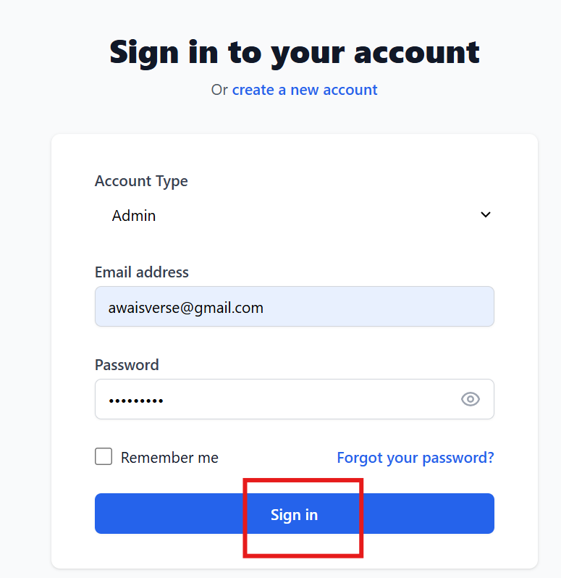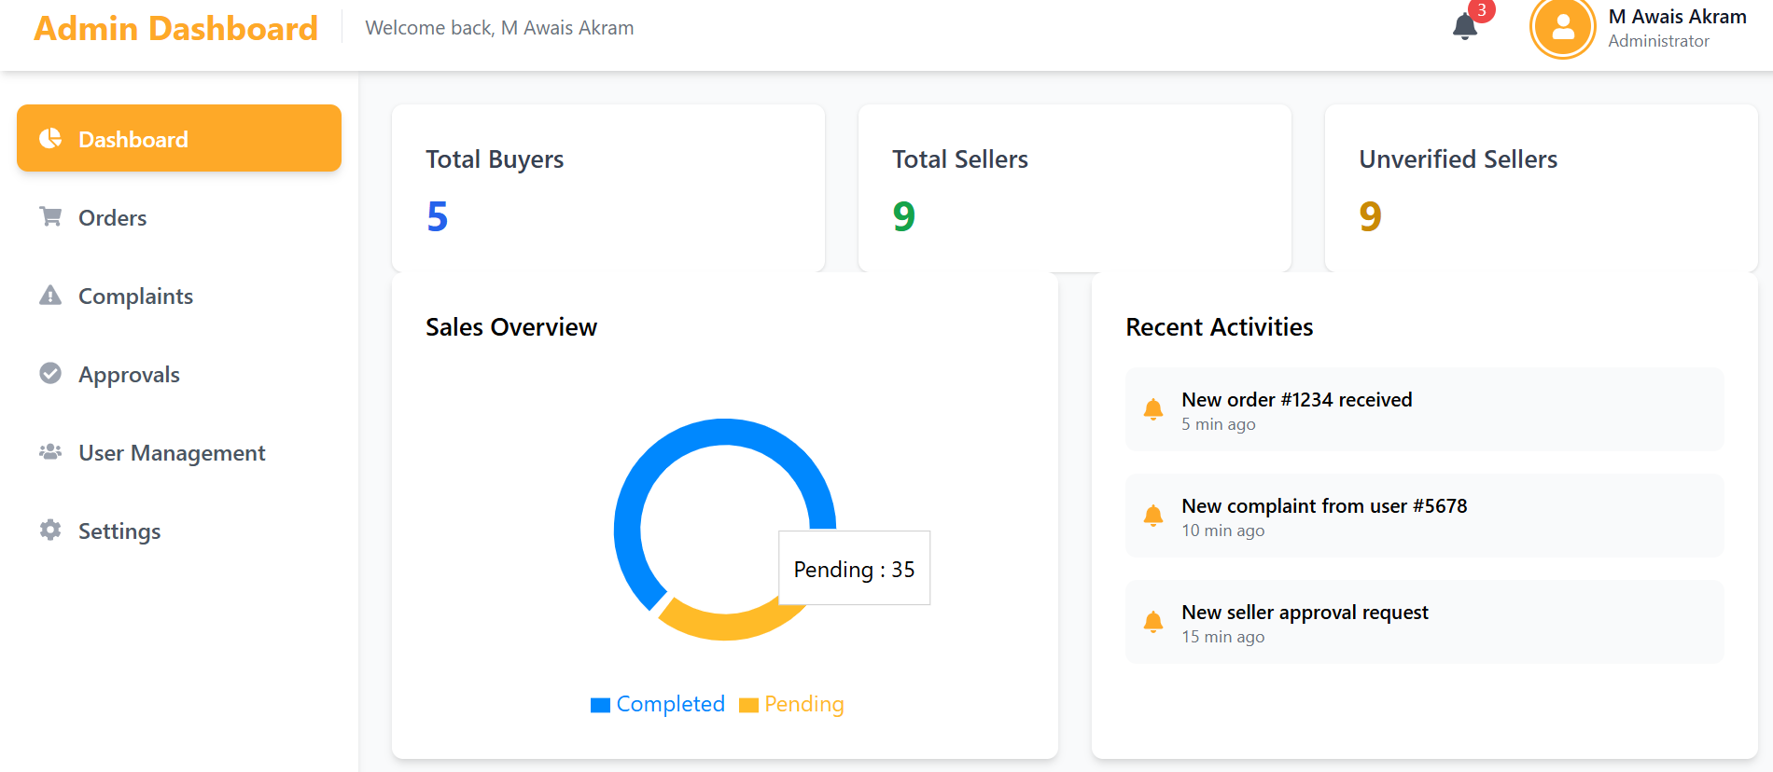

Buyer Side:
